DevOps-Development and Operations

What is DevOps?

DevOps is a set of practices that combines software development ( Dev) and IT operations ( Ops ). It aims to shorten the systems development life cycle and provide continuous delivery with high software quality. DevOps is complementary with Agile software development; several DevOps aspects came from Agile methodology.

DevOps Practices

* CI (Continuous Integration)
* CD (Continuous Delivery)
* CT (Continuous Testing)
* CD (Continuous Deployment)

What is Continuous Integration?

i. Continuous integration is a development practice in which developers are required to commit changes to source code in a shared repository several times a day.

ii. Every commit is the build and this allows the teams to detect problems early.

iii. Practice of continuously integrating code changes. Ensure that any changes pass all tests, guidelines, and code compliance standard.

Benefits:

1. Catch issues fast and nip them in the bud.
2. Everyone can see what’s happening.
3. Automate the build
4. Continuous Integration leads to continuous deployment allowing us to deliver software more rapidly.
5. It provide support for over 1000 plugins.

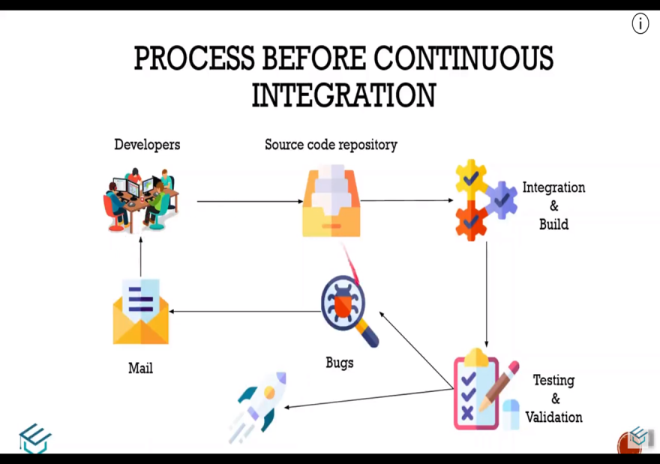

Drawback of the Process:

1. No constant feedback-Developers have to wait till the application is deployed & the QA team verifies.
2. Bug Fixing Costly – Location & fixing the bugs by itself becomes a time consuming process.
3. Slow software delivery – software delivery process became slow & inconsistent with a lot of ifs.

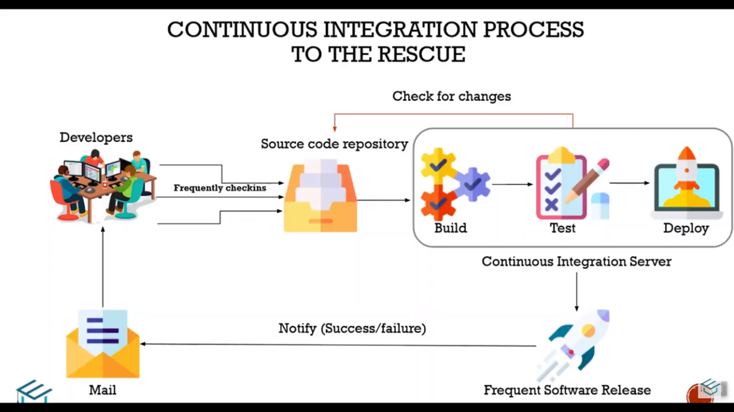

Benefits of the process:

1. Constant Feedback –Developers get constant feedback because of the automated build &test process.
2. Bug fixing Costly – Time taken to identify the cause of the bug is reduced drastically.
3. Fast software delivery – The frequency of the software release increases.

What is Continuous Delivery?

There are many ways an application can be deployed. Most Traditional application deployment models are slow. DevOps adds agile methodologies to the code promotion process. The code promotion and deployment processes are accelerating. Application can now be moved into production on a continuous basis.

Benefits :

1. Immediate bug detection.
2. Automates software release
3. Increase developers productivity
4. A deployable system at any given point
5. Record of evolution of the project
6. Detect system development problems earlier
7. Reduce risks of cost, schedule and budget
8. Measurable and visible code quality.

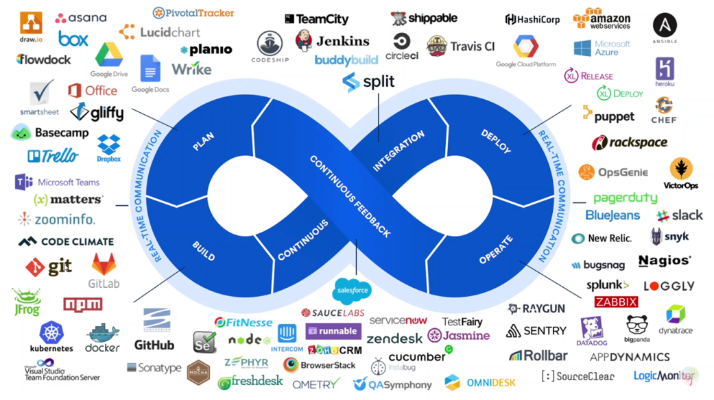

What is Jenkins?

Jenkins is the leading open source continuous integration tool. Jenkins builds and tests our software continuously and monitors the execution and status of remote jobs, making it easier for team members and users to regularly obtain the latest stable code. Jenkins works with other tools to continuously integrate and deliver the code. Core Jenkins is not really complicated. Jenkins is basically a scheduler on steroids. Code builds are performed on a triggering event. Jenkins uses pipelines to breakdown builds into smaller manageable pieces.

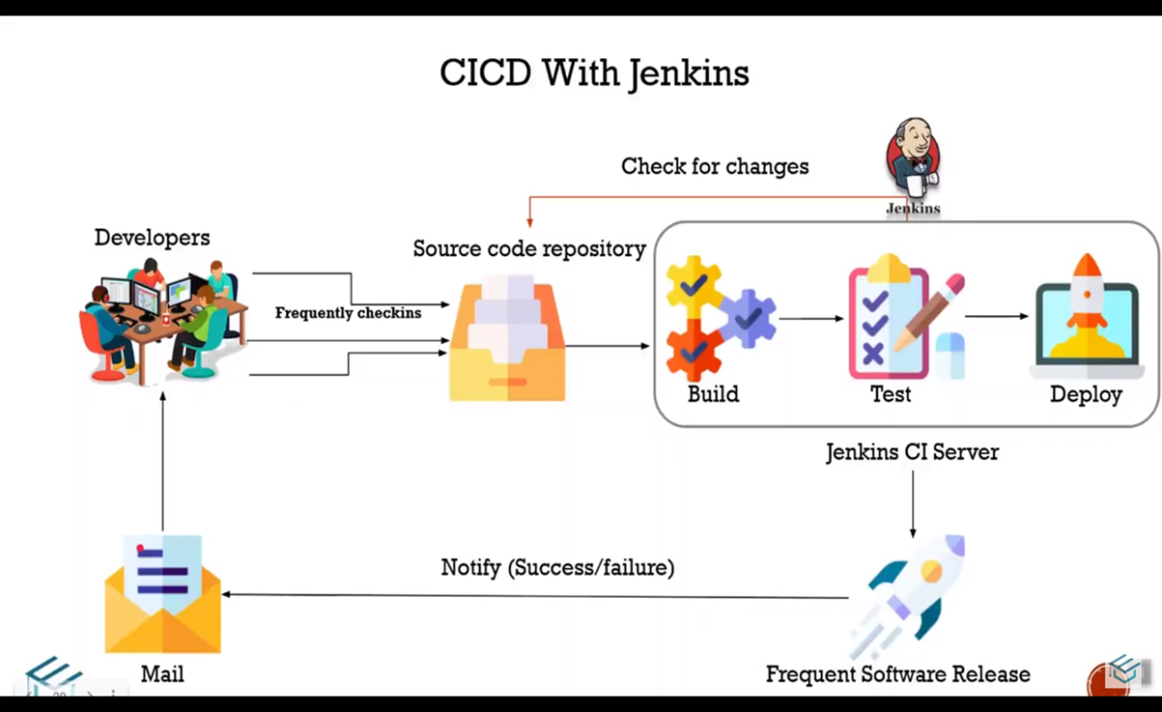

Features of Jenkins

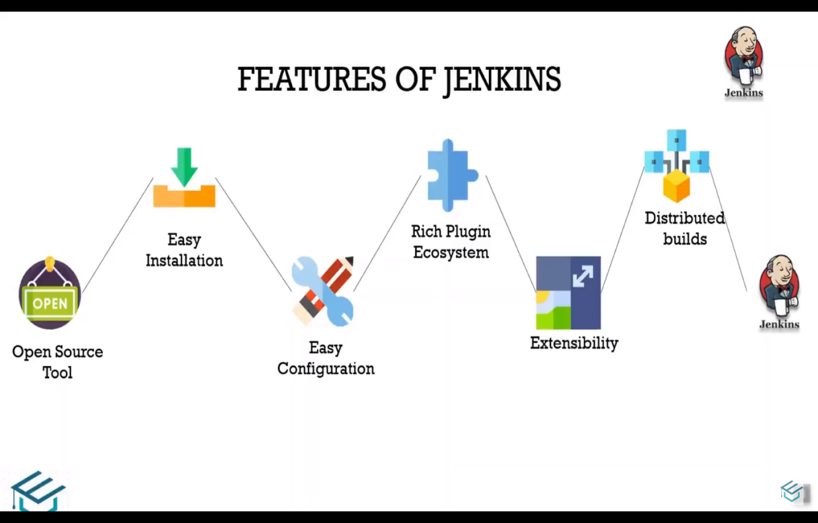

Jenkins Distributed Architecture

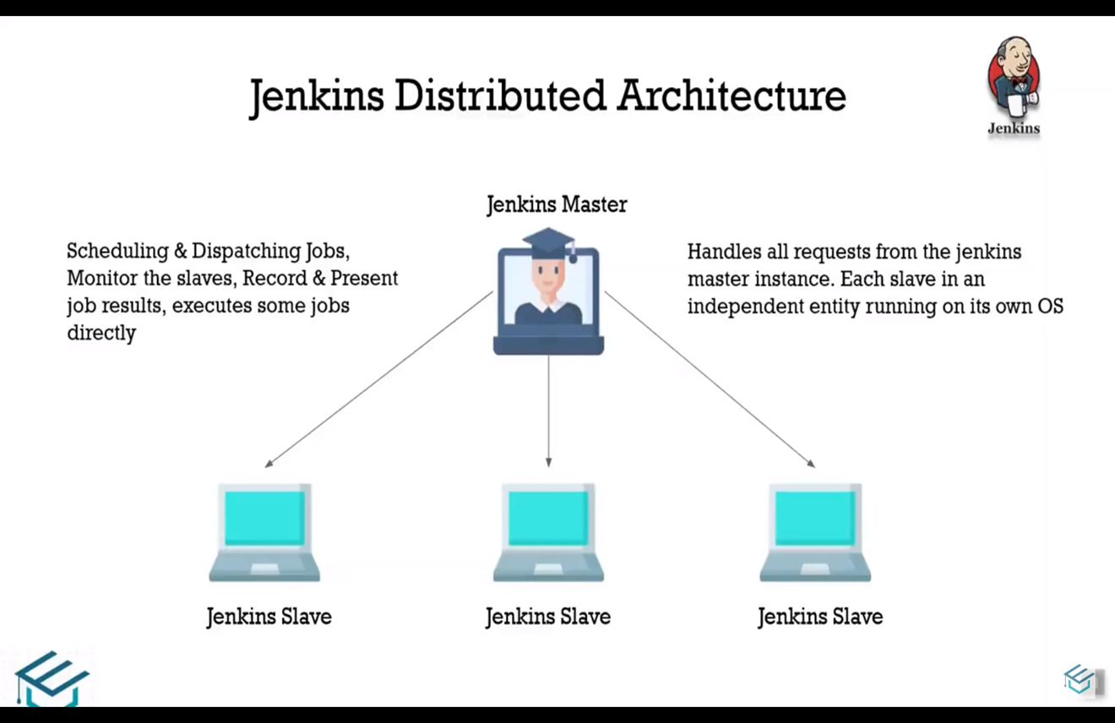

Jenkins For a Developer:

1. Easy to Install
2. Easy to use – Create a new job-checkout and build a small project- checkin a change-Create a test-watch it build and run-Fix a test
3. Multi technology - Build C, Java, C#, Python, Perl, SQL, etc
4. Test with Junit, Nuit, MStest, etc

More Power-Jenkins Plugins

Jenkins has over 300 plugins

1. Software configuration management
2. Builders
3. Test frameworks
4. Virtual machine controllers
5. Notifiers
6. Static analysis

Build Tools

1. Ant
2. Maven
3. Msbuild
4. Cmake
5. Gradle
6. Grails
7. Scons
8. Groovy

Test Frameworks

1. Junit
2. Nuint
3. MSTest
4. Selenium
5. Fitnesse

Notification

1. Twitter
2. Campfire
3. Google calendar
4. IM
5. IRC
6. Lava lamp
7. Sounds
8. Speak

Authorization

1. Active directory
2. LDAP

Virtual Machine

1. Amazon EC2
2. VMWare
3. VirtualBox
4. Xen
5. Libvirt

Process

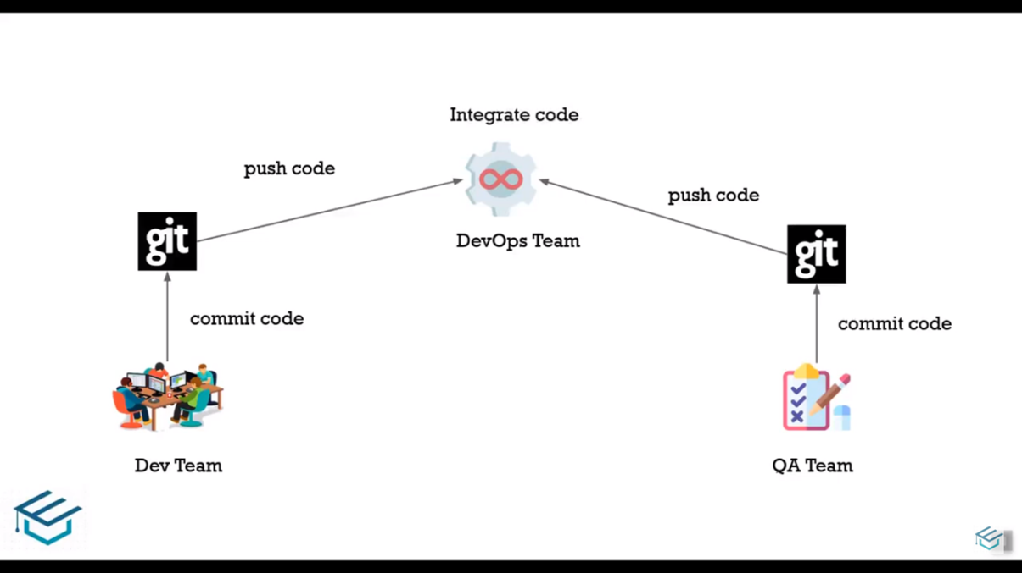

Pipeline Flow

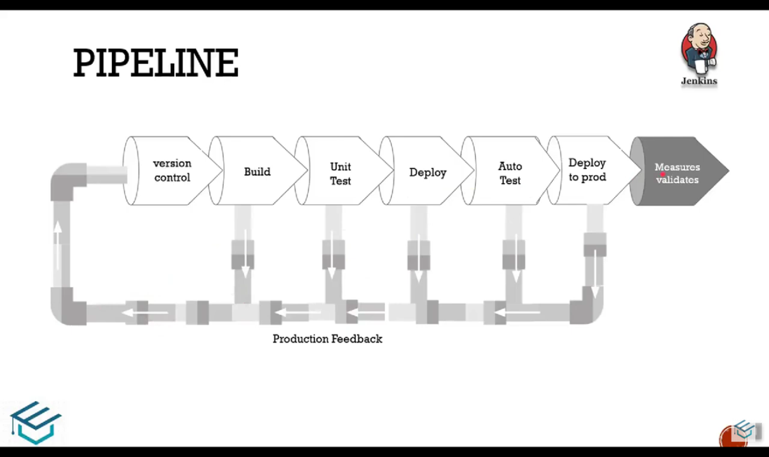

Key Feature of Pipeline:

1. Pipeline as code
2. Code can be checked into VCS
3. User input
4. Resume the job execution at the same time
5. Integrate other plugins
6. Allows conditional loops (where, when)

Jenkins Declarative Pipeline

Declarative pipeline is a relatively new feature that supports the pipeline as code concept. It makes the pipeline code easier to read and write.

This code is written in a Jenkinsfile which can be checked into source control management system such as Git.

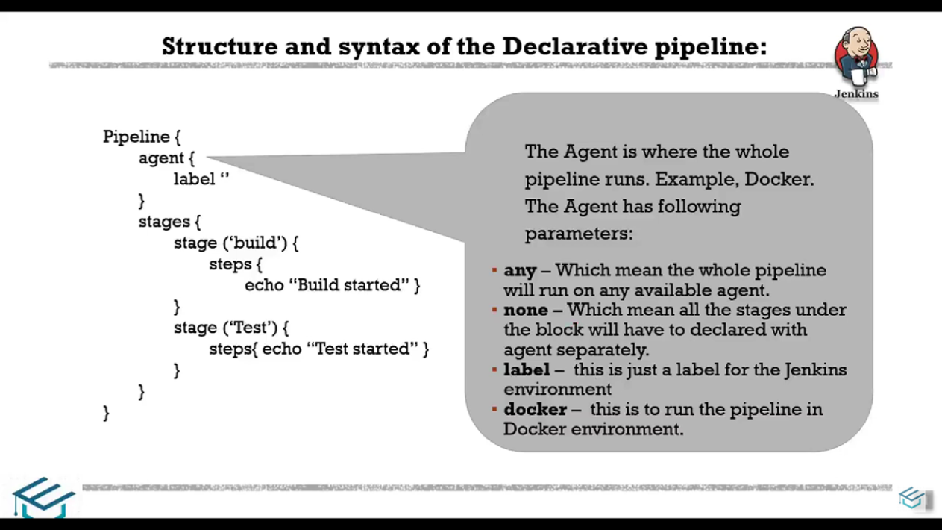

Jenkins Scripted Pipeline

The scripted pipeline is a traditional way of writing the Jenkins pipeline as code. Ideally, scripted pipeline is written in Jenkins file on web UI of Jenkins.

Unlike declarative pipeline, the scripted pipeline strictly uses groovy based syntax. Since this, the scripted pipeline provides huge control over the script and can manipulate the flow of script extensively.

This helps developers to develop advance and complex pipeline as code.

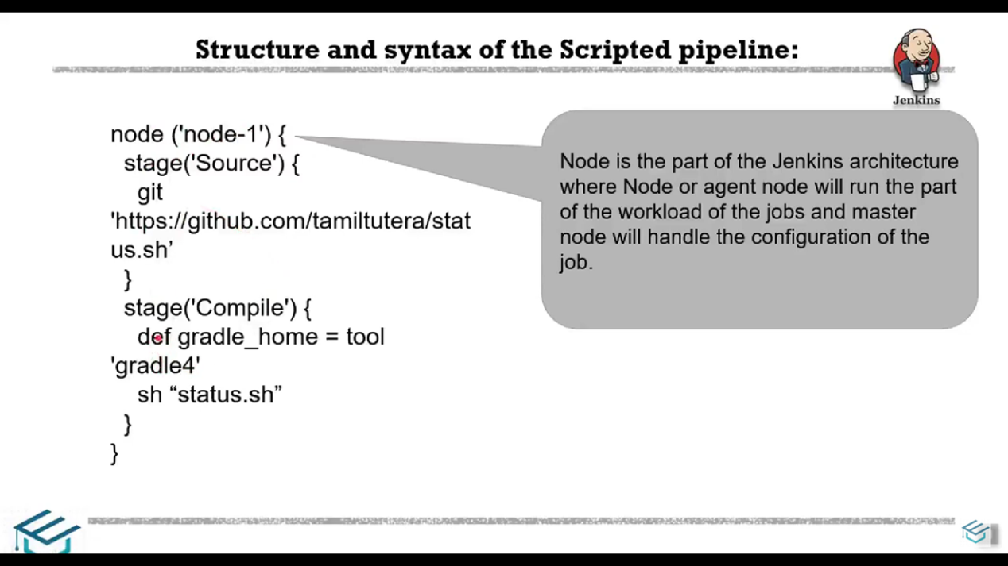

Master and Slave Nodes in Jenkins

1. Master/Slave
2. Slaves are small java “client processes connected to the masters”
3. Uses JNLP (Java Network Launch Protocol)
4. Spread the load of intensive build processes
5. Delegate tasks to specific machines
6. Can be created on any platform

Setting up and Preparing slave Nodes

1. Setting up slave nodes

* Using basic credentials (Username/Password)
* Using SSH keys (Secure Shell Home)

1. Prepare nodes as slaves

* Create Jenkins user
* Login as the created user
* Create a Jenkins slave directory
* Install JRE( Java user)

Maintaining Jenkins

1. Analyze the build logs in JENKINS_HOME
2. Copy all settings build jobs and archives of artifacts
3. Copy it back when needed
4. Archive jobs that are not used
5. Various plugins available for backup- thinbackup

Which Part of Embedded Can use in DevOps?

* Firmware development
* Verification & Validation or Test /Integration
* IoT Development

What are the Tools Required to Implement CI/CD?

1. Jenkins
2. GitHub
3. Maven (Recommended for Java user)
4. Server- Apache Tomcat, Jetty, J Bass, Glass fish

Deploying Jenkins in public cloud:

* AWS- Amazon Web Services
* Azure
* Google Cloud
* IBM cloud
* Oracle cloud infrastructure
* Civo kubernetes

**Global Tool Configuration**

Step 1: To Sign in Jenkins Tool, then go to Manage Jenkins Tab.

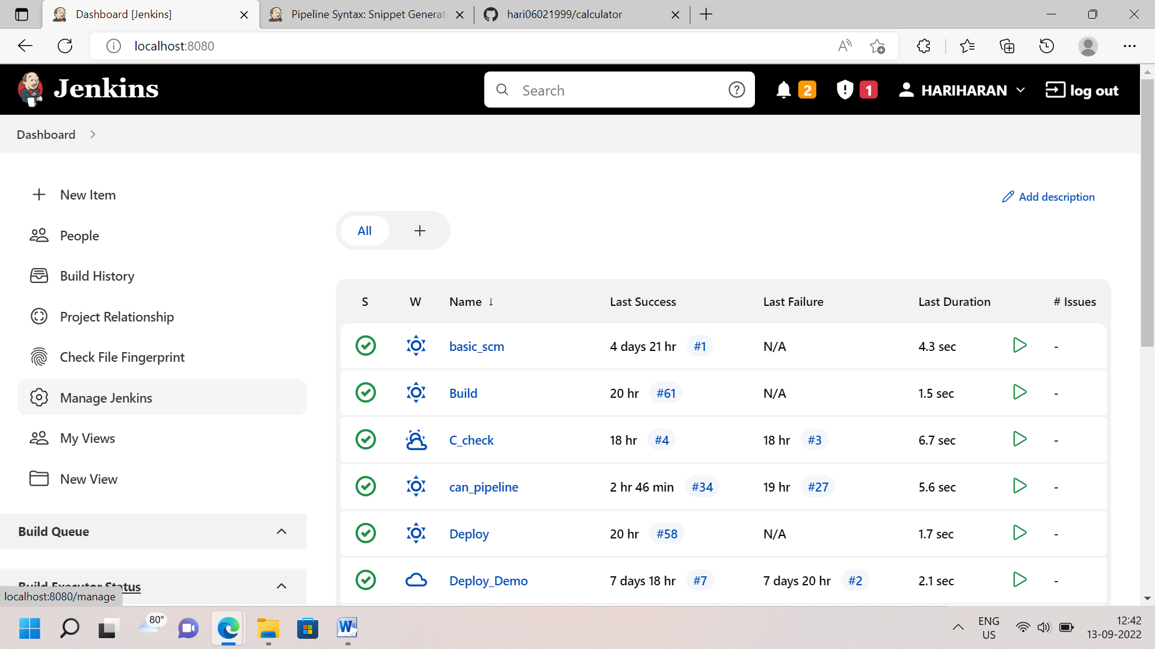

Step 2: Go to System Configuration. Click global tool configuration 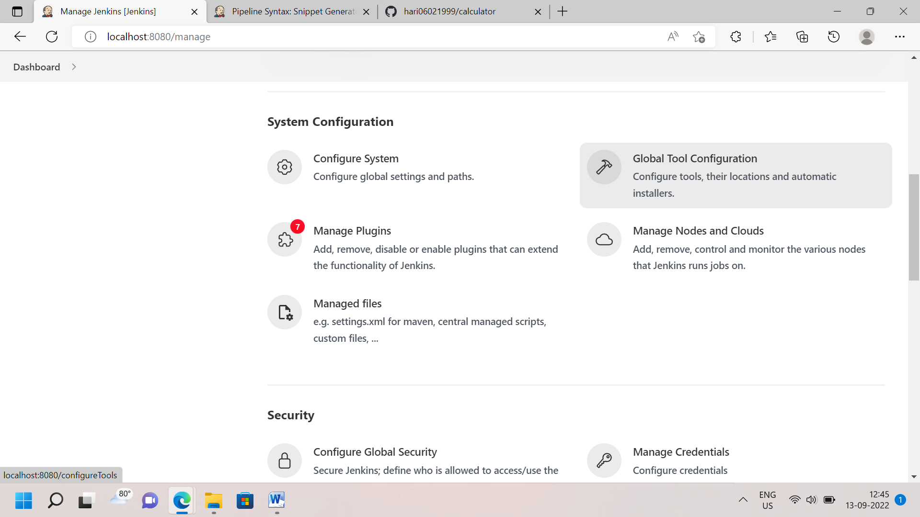

Step 3: Go to Git Configuration. Click Add Git, To put Git name and To Paste Git Installation Path. If complete configuration click apply and save. 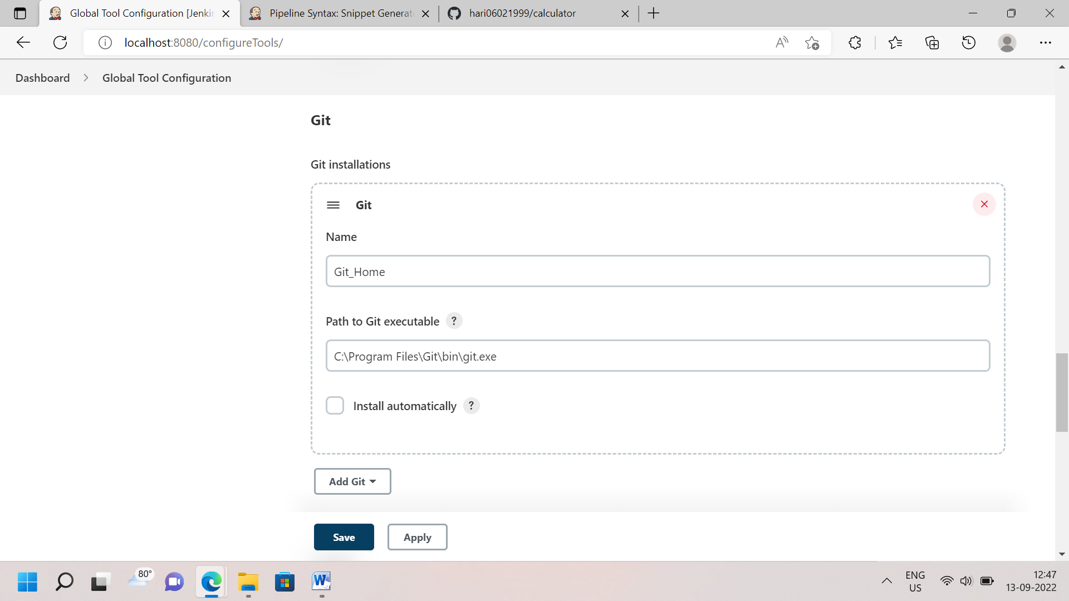

Step 3: If you use java program, Go to JDK Configuration. To put JDK name and To past JDK InstallationPath. 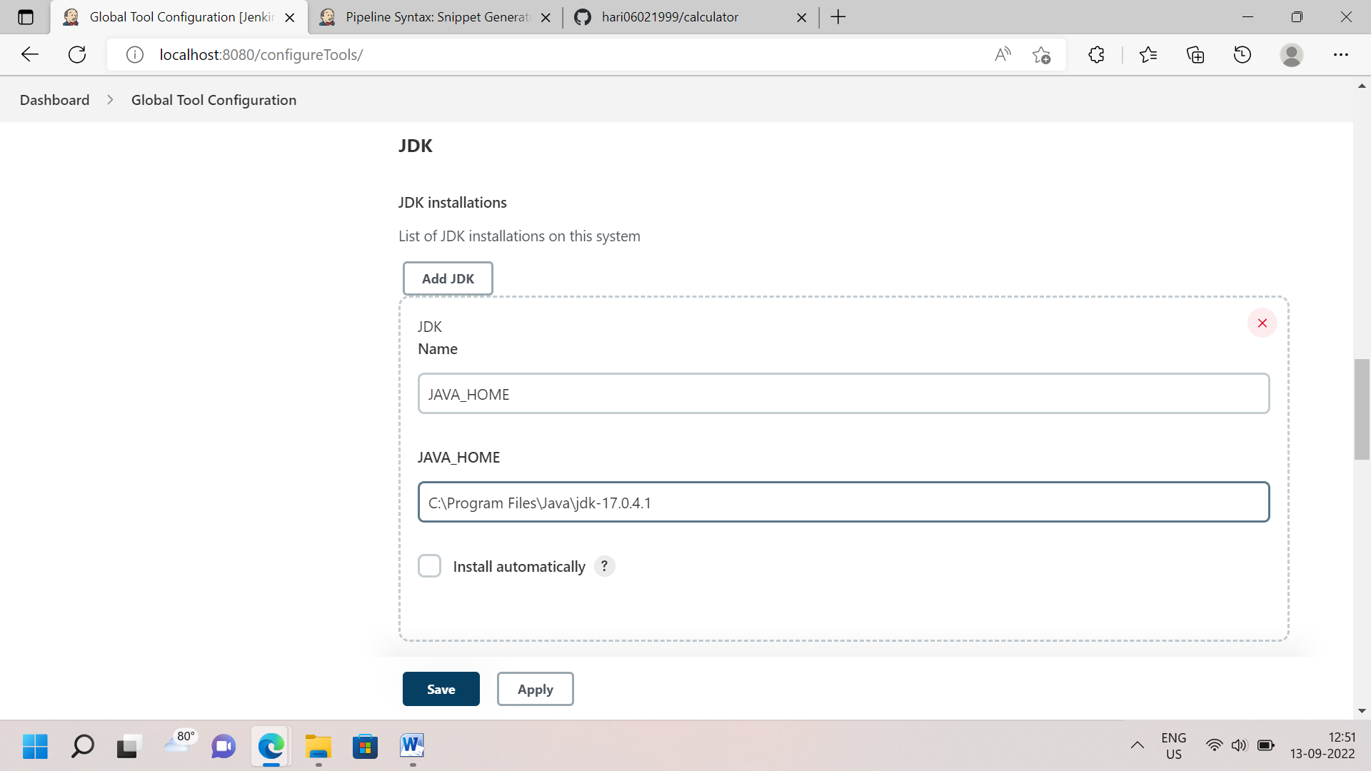

Step 4: Then Maven tool configuration for java program. Its use for Build Java Program. Go to Maven Configuration. To put Maven name and to paste Maven Installation Path. 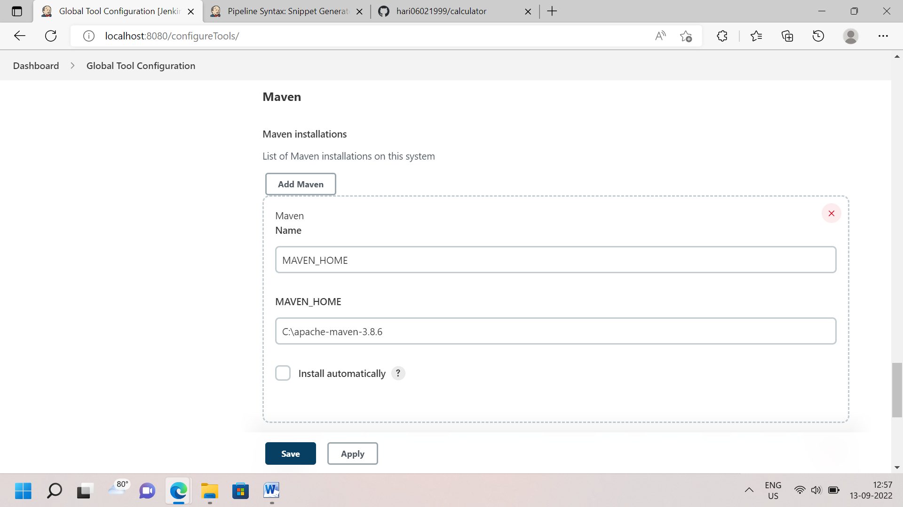

Step 5: Previous step are completed. Then go to Window search bar, Search Edit a System Environment Variables. Open the tab and Click Advance Tab then Click below Environment Variable.

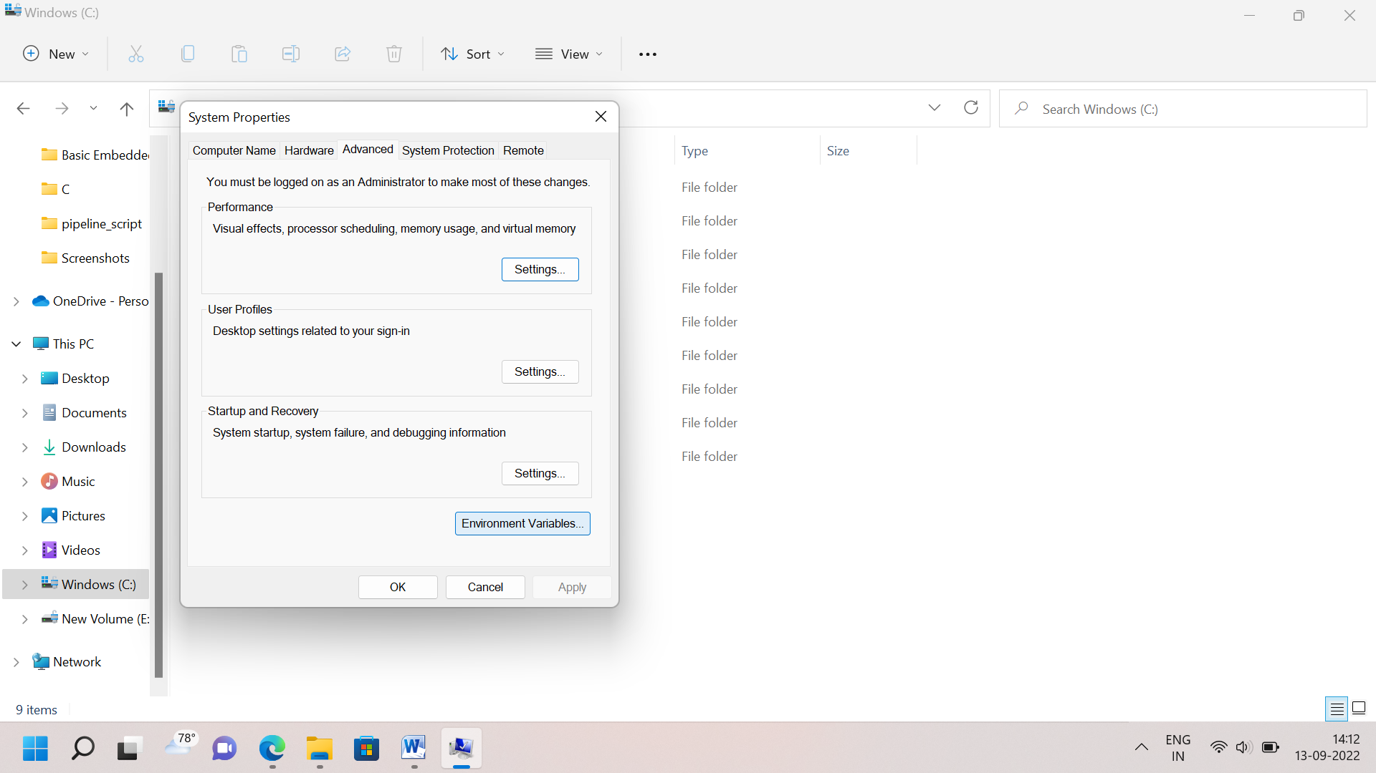

Step 6: Go to System Variable. Click New and then Put Variable name and Variable value is nothing Java and Maven Installation path. Both variable create it separately 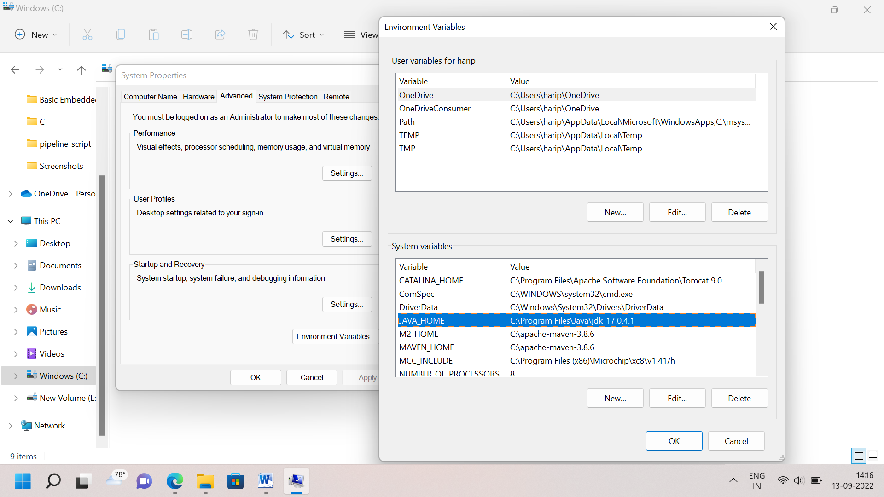

Step 7: Go to Path variable Edit option, Click new tab and paste it Git, java and maven installation path with bin file. 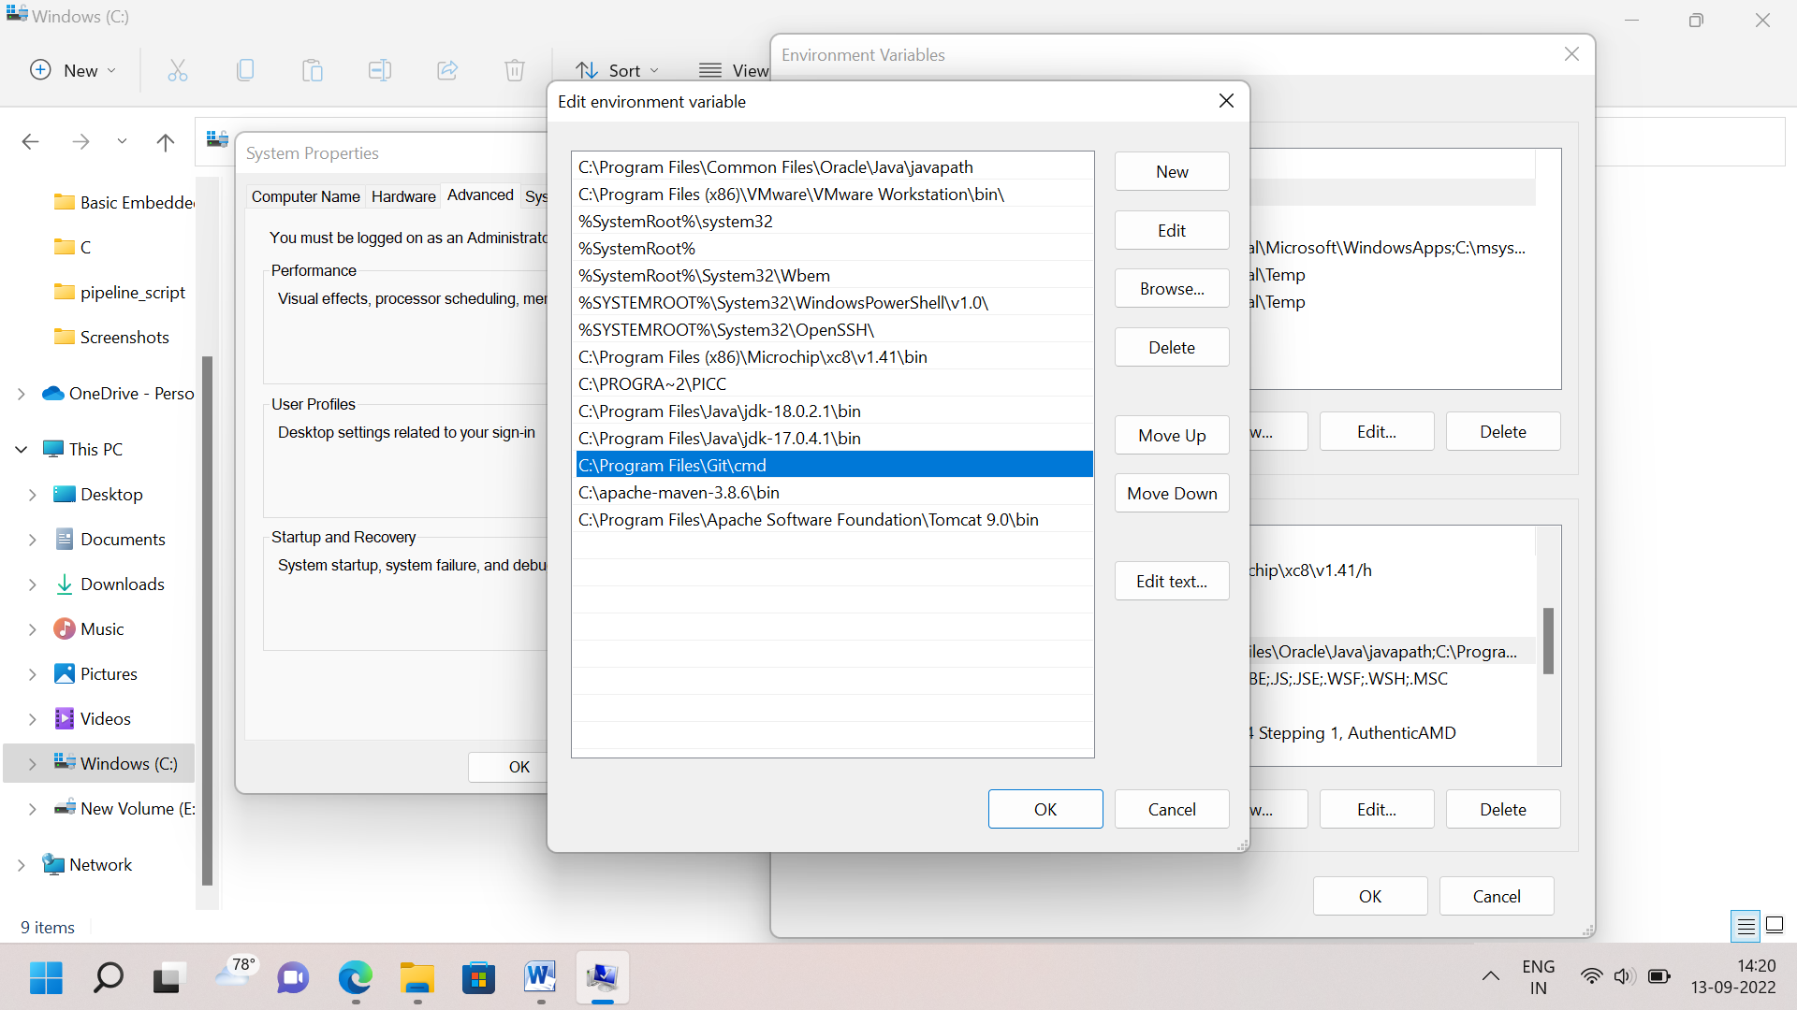

**How to Make Freestyle Project in Jenkins?**

Step 1: Go to Dashboard in Jenkins Tool. Click New Item Tab. To Put Job name and Choose Freestyle Project and Click Ok Tab. 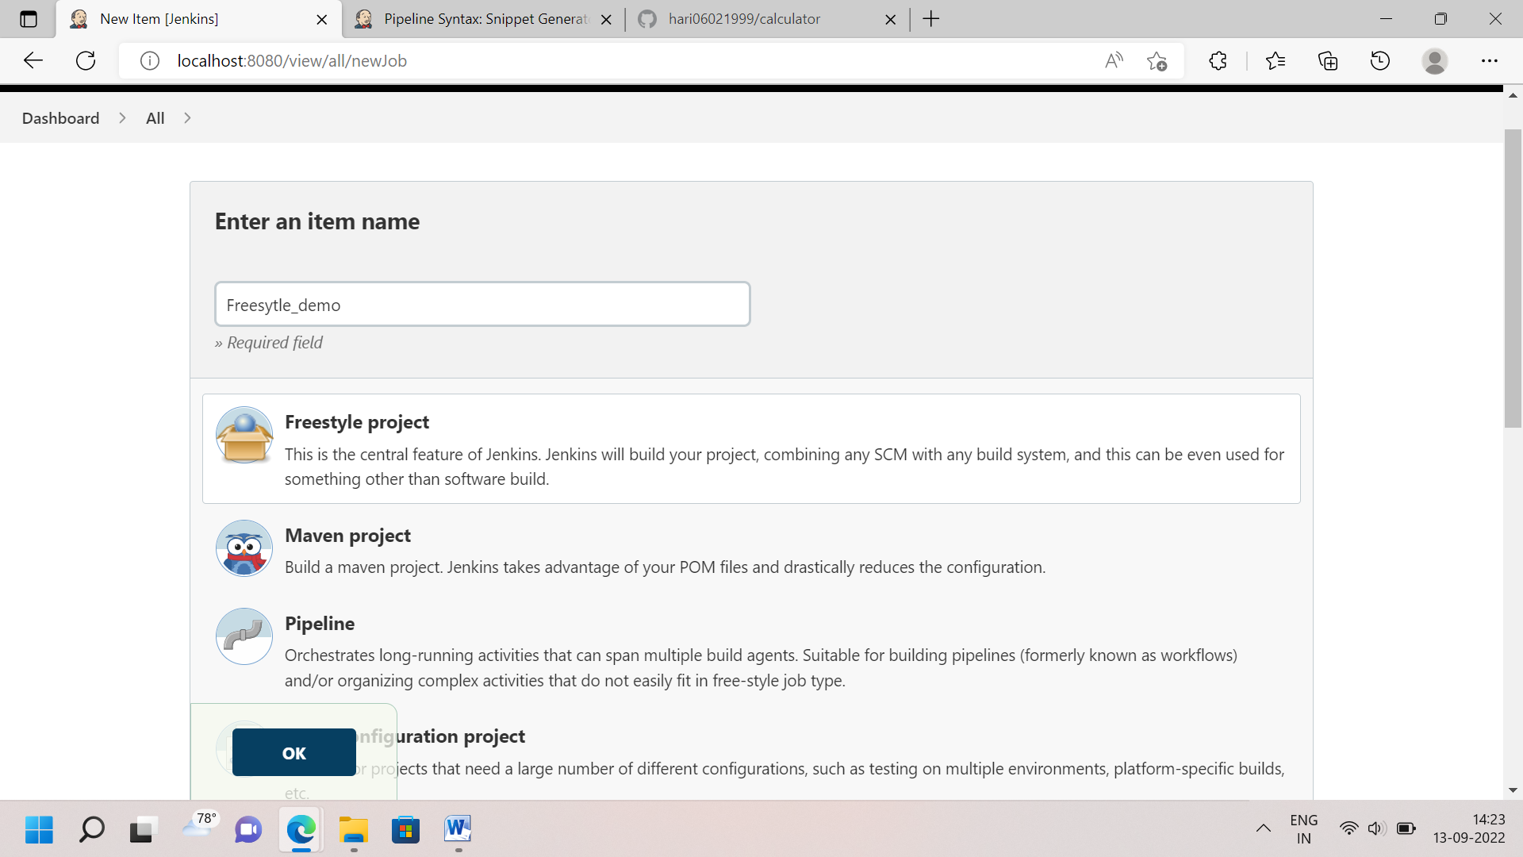

TYPE 1: **Without SCM and Build Trigger**

Step 1: Click Configure Tab then Go to General Tab Click advance option and choose Use Custom Workspace To Paste the Program Directory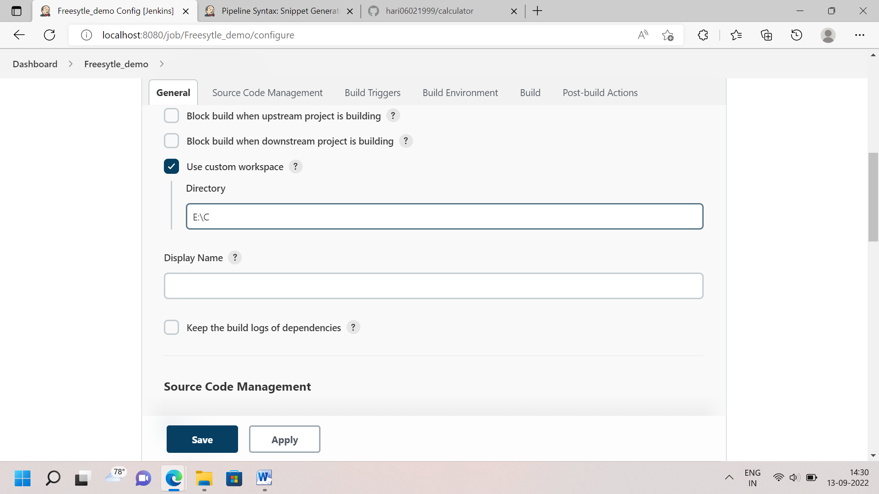

Step 2: Go to Build Tab, We choose Execute batch Command and write Command to apply and save. 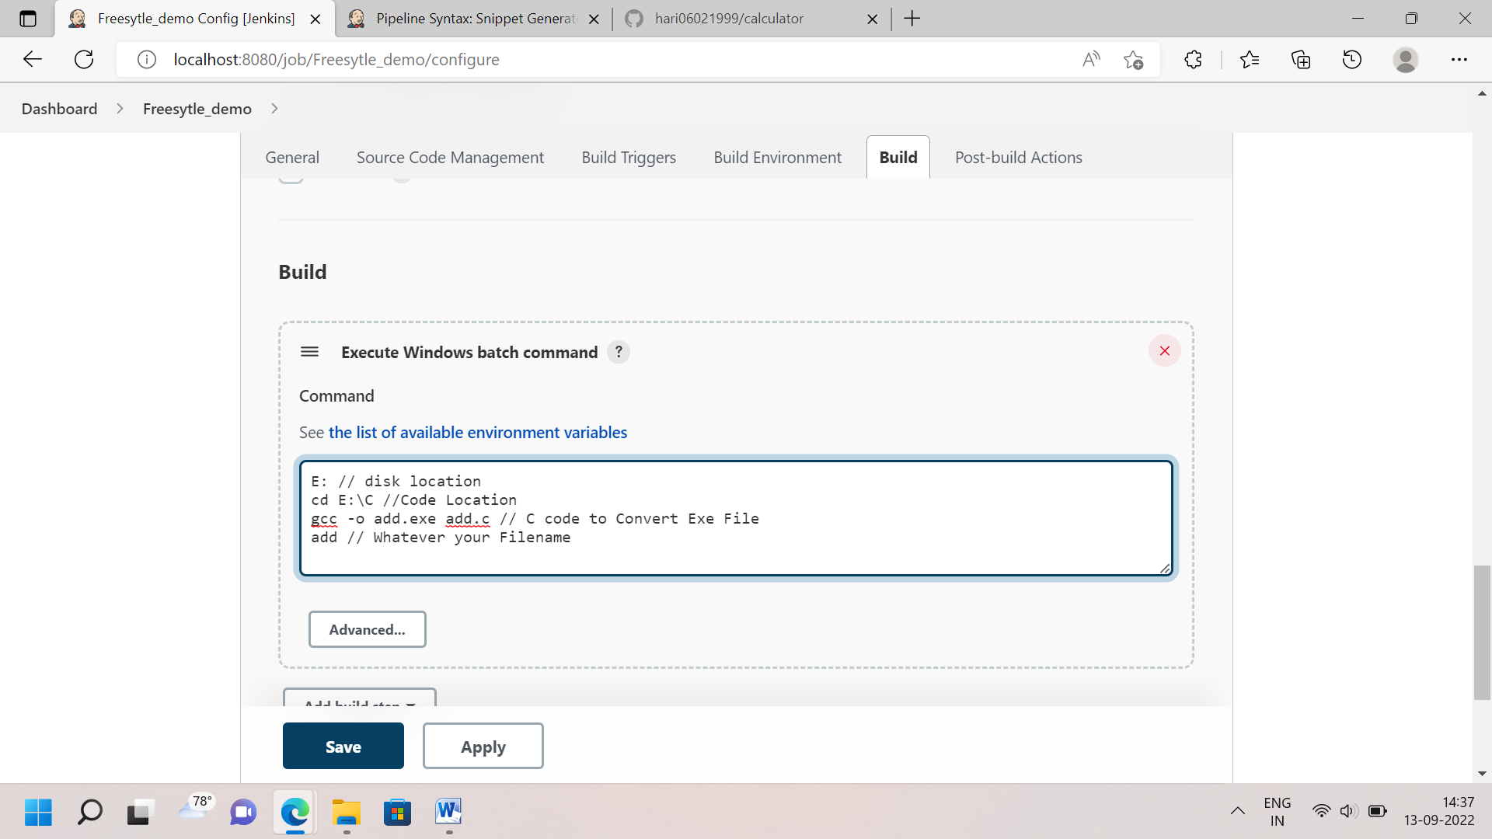

Step 3: Click build Now tab and click build history to view Console Output. I’m Already create exe file so it show gcc is not recognized. 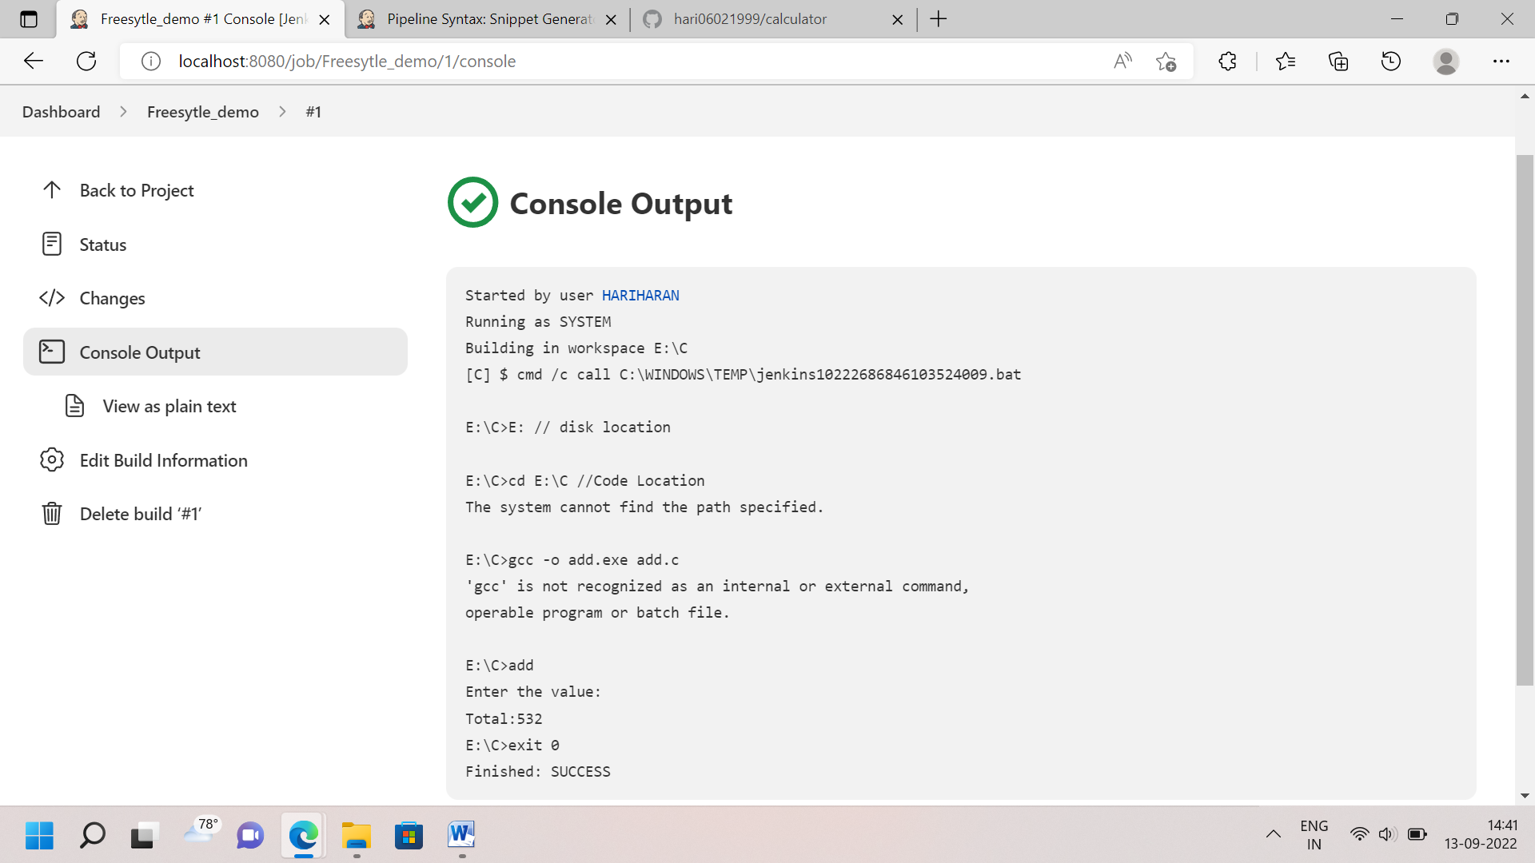

Type 2: **SCM using with help of GitHub**

Step 1: I’m creating Git repository and upload C and Exe file in master branch and Copy the that particular repository link 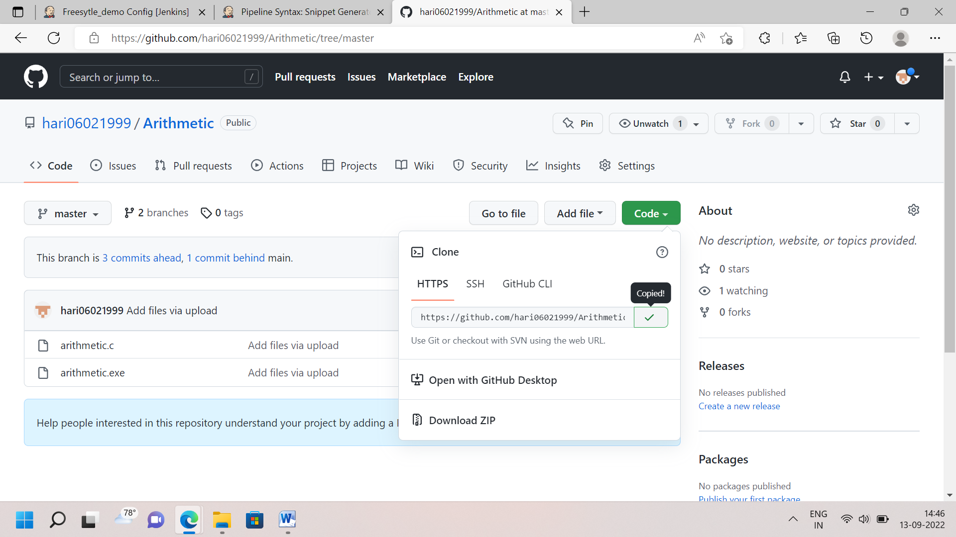

Step 2: I’m choosing SCM Tab for Clone Git and Jenkins and To paste the link in SCM, If your git repository is Private to put it your credential. 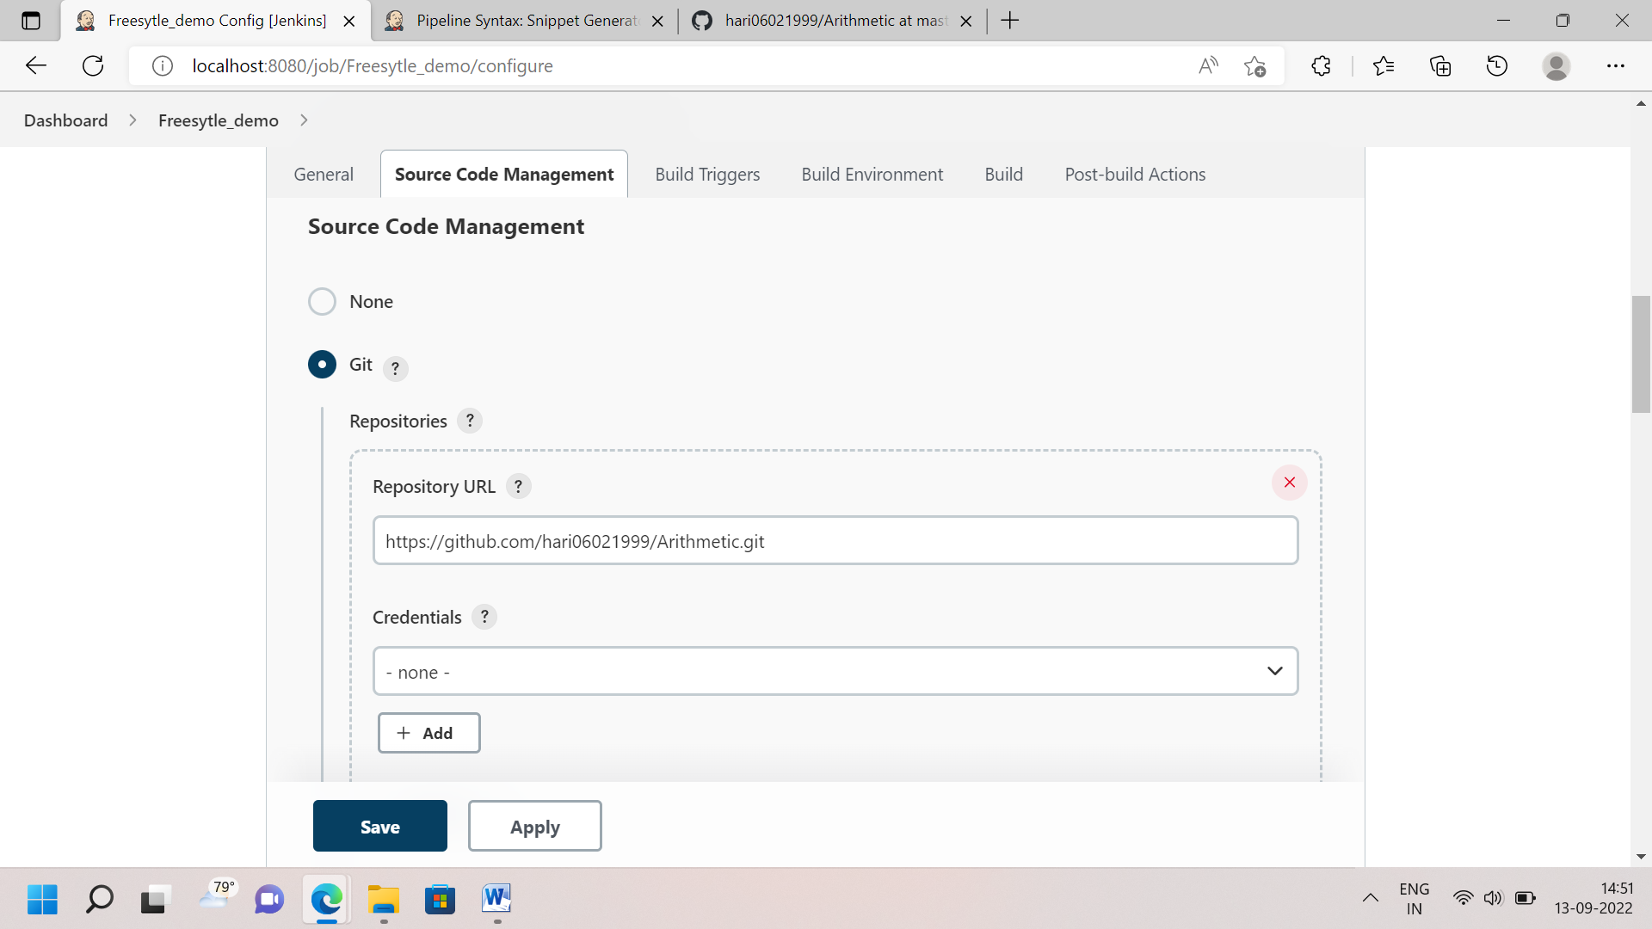

Step 3: Then Build using Windows batch command. i write only file name in command , Apply and save.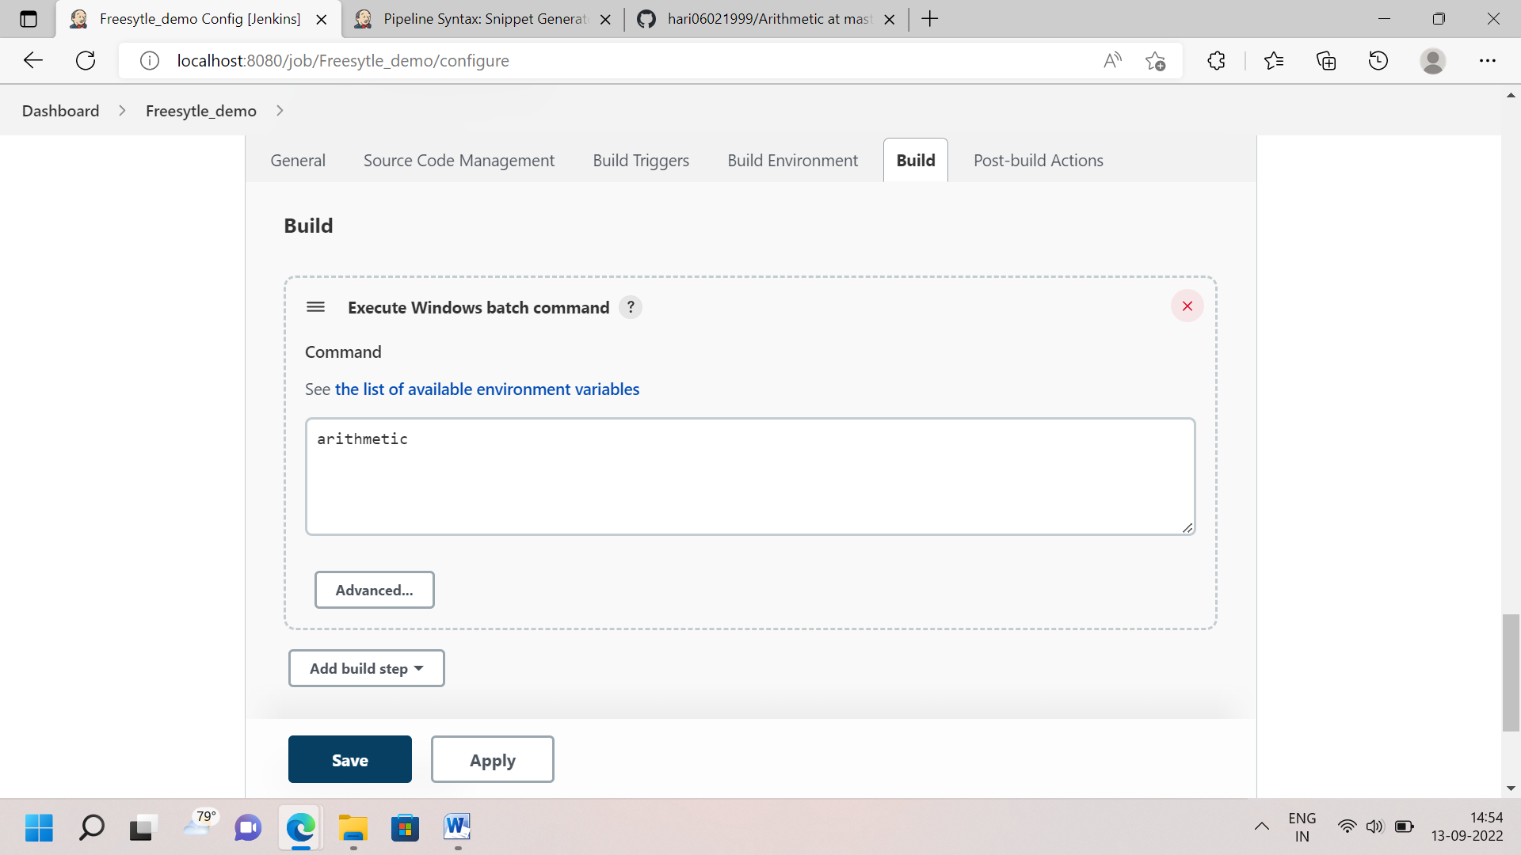

Step 4: Build now and to view Console output. 

Type 3: **Build Periodically (Schedule)**

**Template:**

Minute(0-59), Hour(0-23), Day(1-31), Month(1-12), Day of the Week(0-6)

Reference link: [Schedule Jenkins build periodically - hourly, daily, weekly. Jenkins schedule format | Lenar.io](https://www.lenar.io/jenkins-schedule-build-periodically/)

Example:

If build daily at 8:30 in the morning..

* Monday to Friday : 30<Space>08<Space>*<Space>*<Space>1-5

If build every day at 8

* *<Space>08<Space>*<Space>*<Space>*

Step 1: Follow the Previous Type of SCM, and I go to build trigger – choose build periodically To put the format like * * * * * . It will build Every minutes 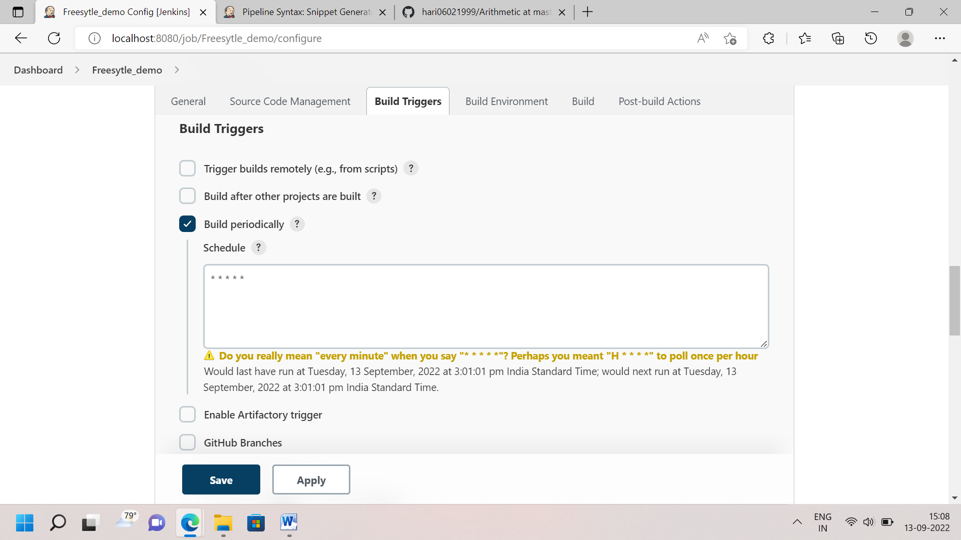

Step 2: Build now . It’s automatically build every minutes in build history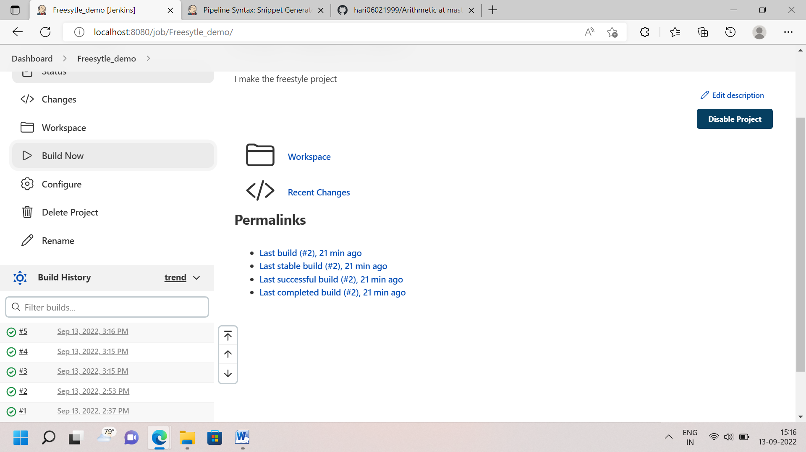

Type 4: **Build based a project on other project (Based on ‘echo’ command)**

Step 1: To create different job in Freestyle project. For Example I have to take four job like Build, Test, Deploy and Release.

Step 2: Go to build trigger – choose build after other projects are built. Go to next job to put privous job name and choose trigger only if build is stable. Similarly I did same procedure other job. 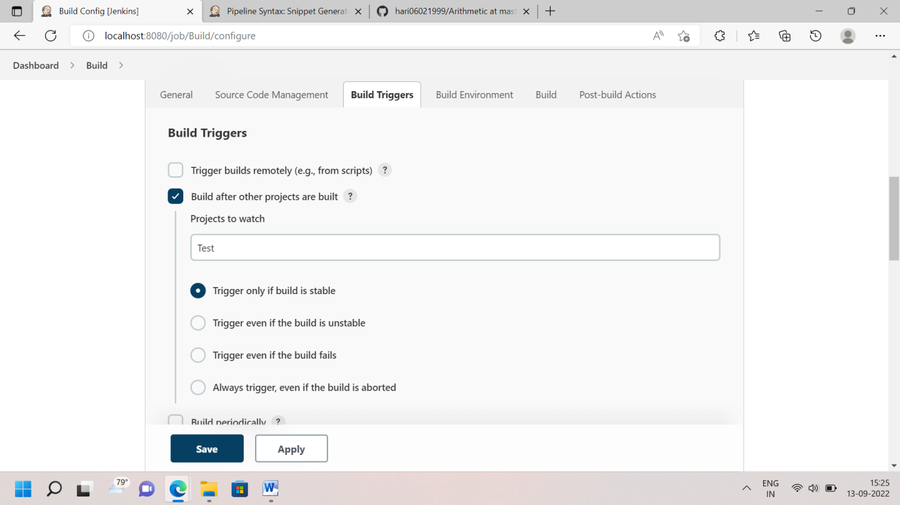

Step 3: Open windows batch command and Put echo command . Apply and save.

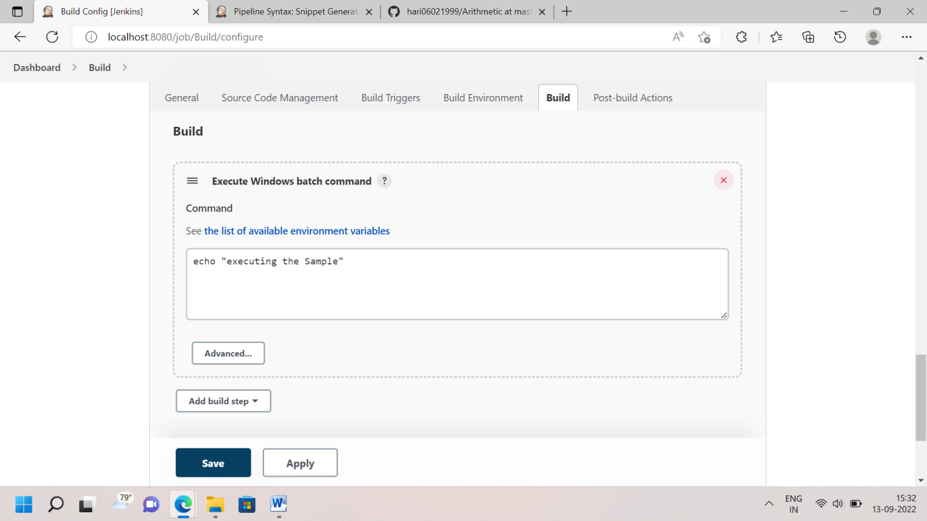

Step 4: It work as a Upstream and downstream project. Click Build now in First job its build and other job it automatically build. If any job is not build, I will stop the build process. 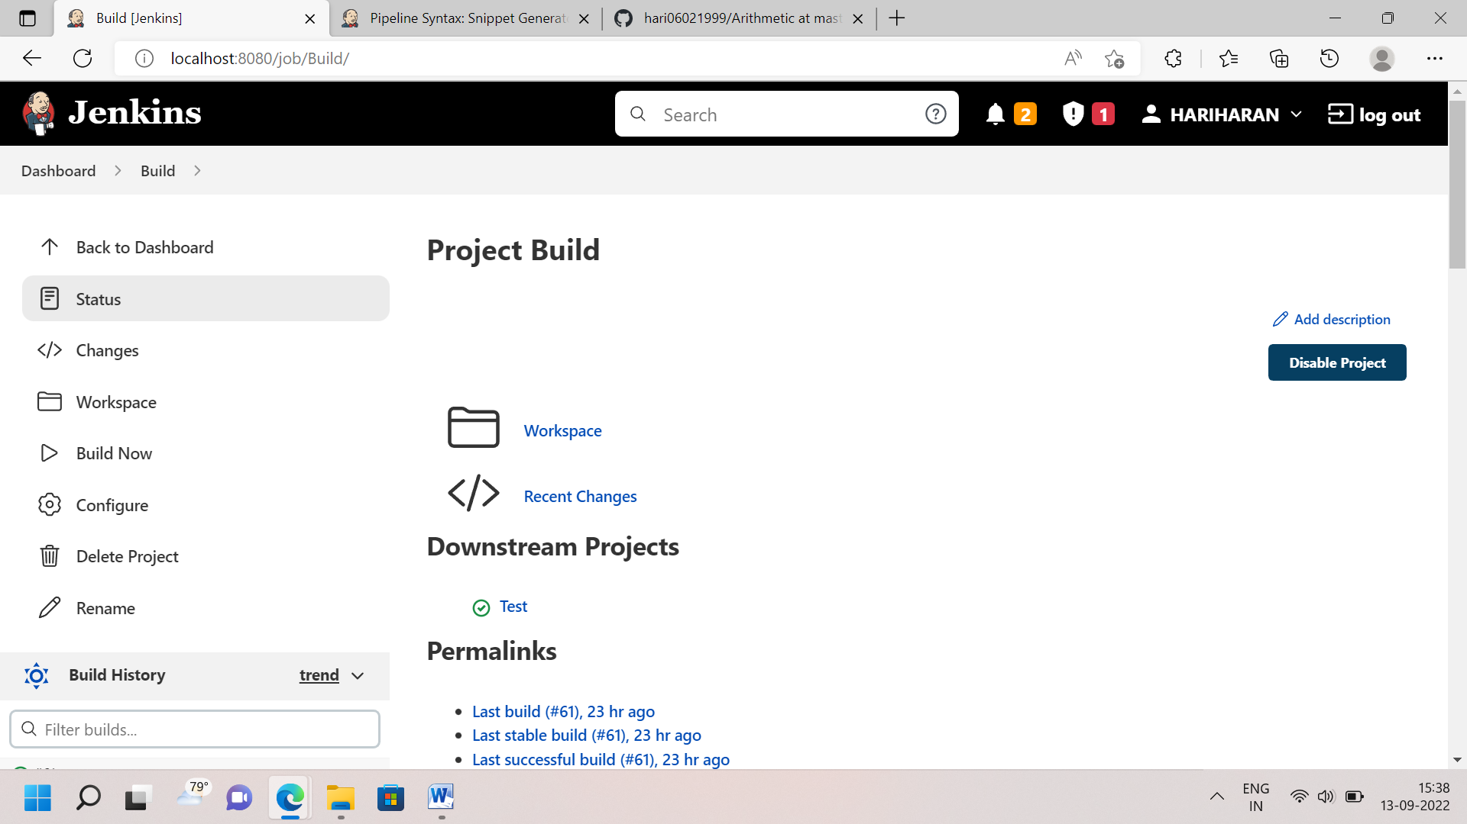

**How to Make Pipeline Project in Jenkins?**

1. Declarative Pipeline Script

TYPE-1: Pipeline Script Mode – Echo based Hello World

Step1: I create new item, I put name and choose pipeline project. 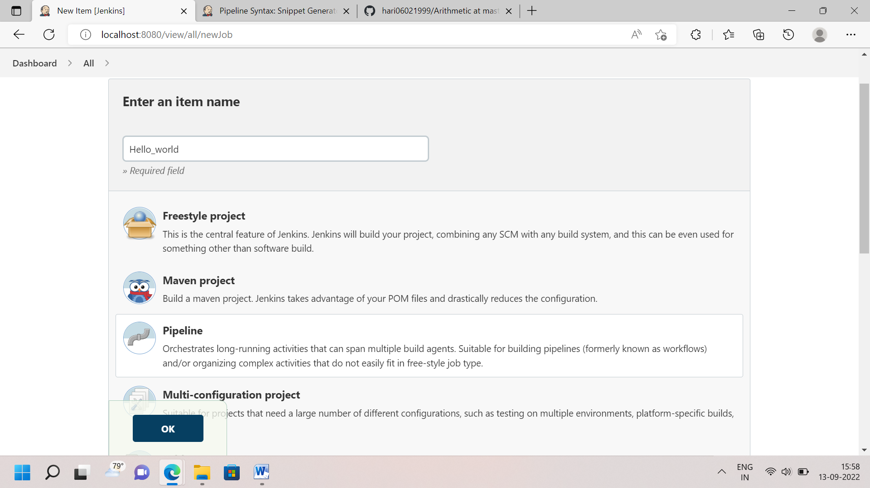

Step 2: Directly I go to pipeline tab and write Declarative pipeline syntax used in echo command 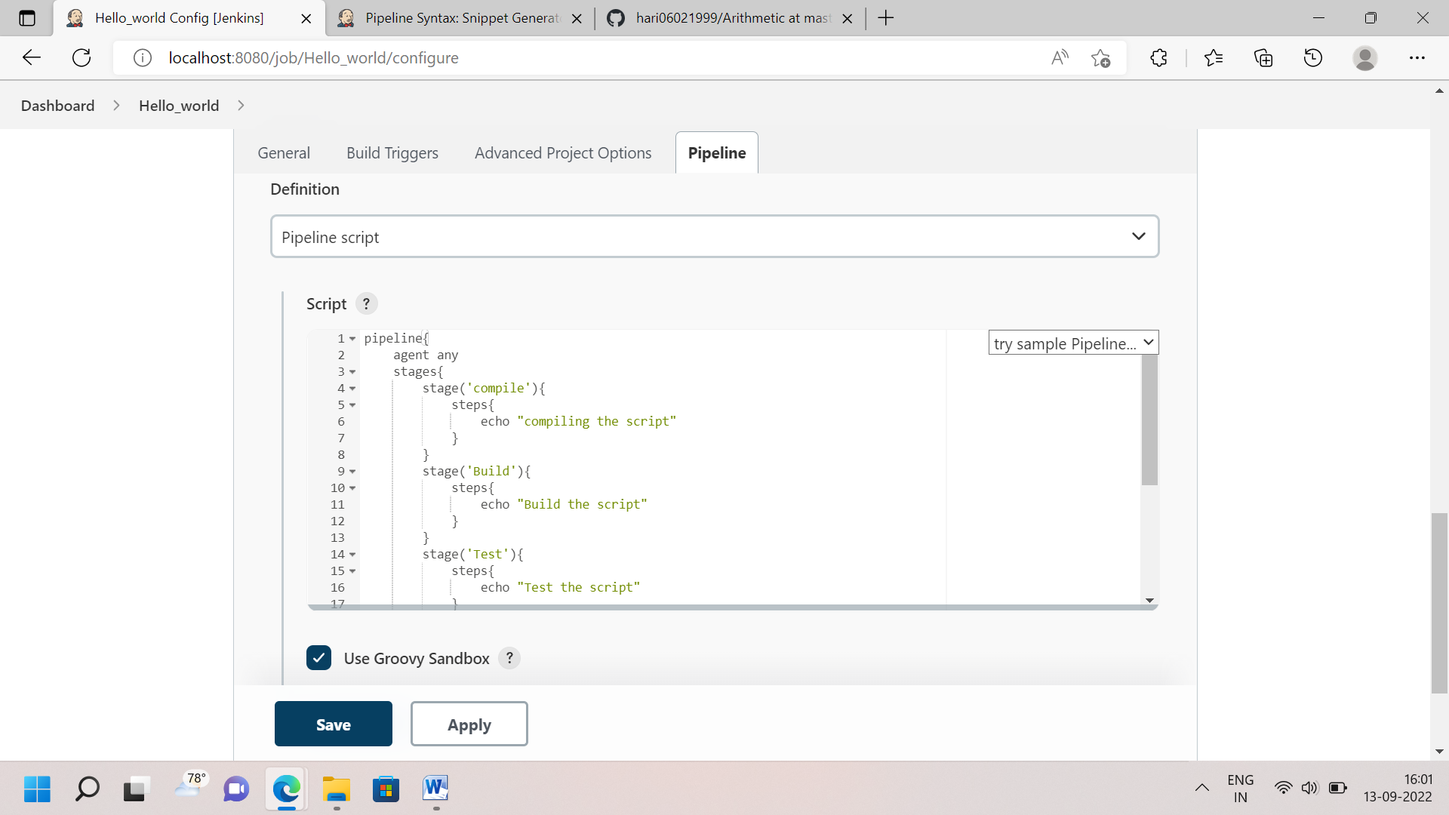

Step 3: Apply and Save. Build now.. it’s automatically build stage by stage

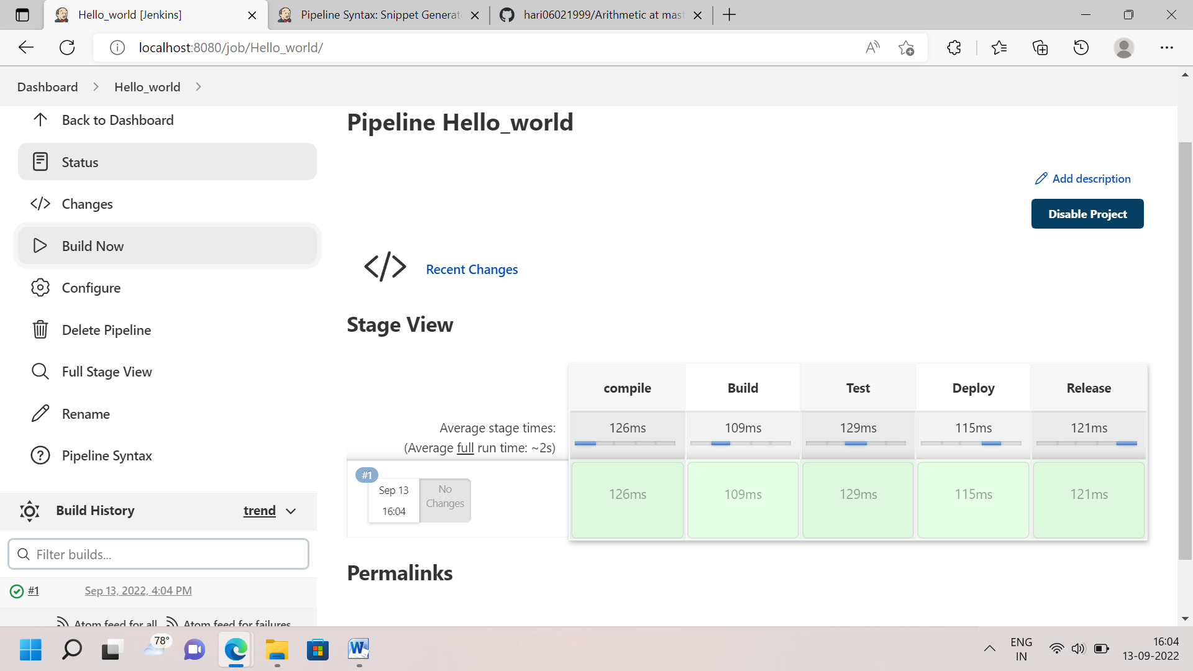

TYPE-2: Pipeline Script Mode – Basic C

Step 1: First I have to checkout Github.So I click pipeline syntax, then opening Snippet Generator and I choose Checkout step. Copy the Git repository link to paste it snippet generator and verify the branch in same Both like Git and Jenkins.Finaly click Generate Pipeline script and copy the script.

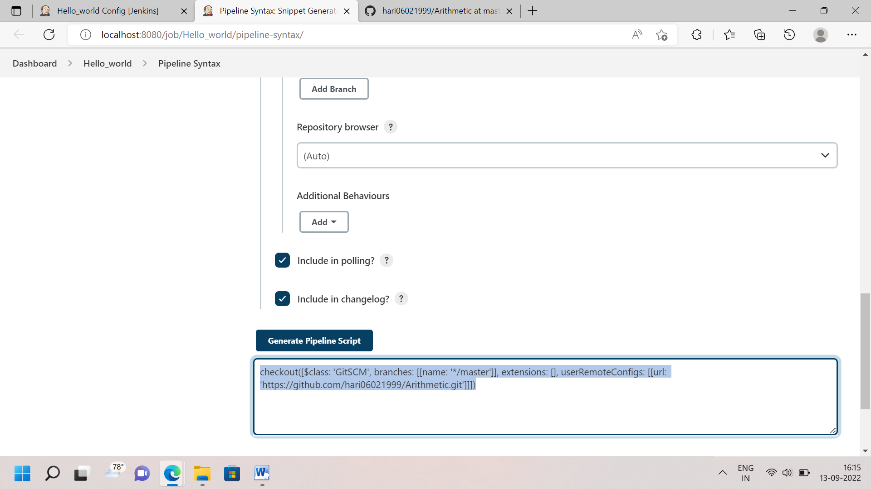

Step 2: To paste in Pipeline script – checkout stage

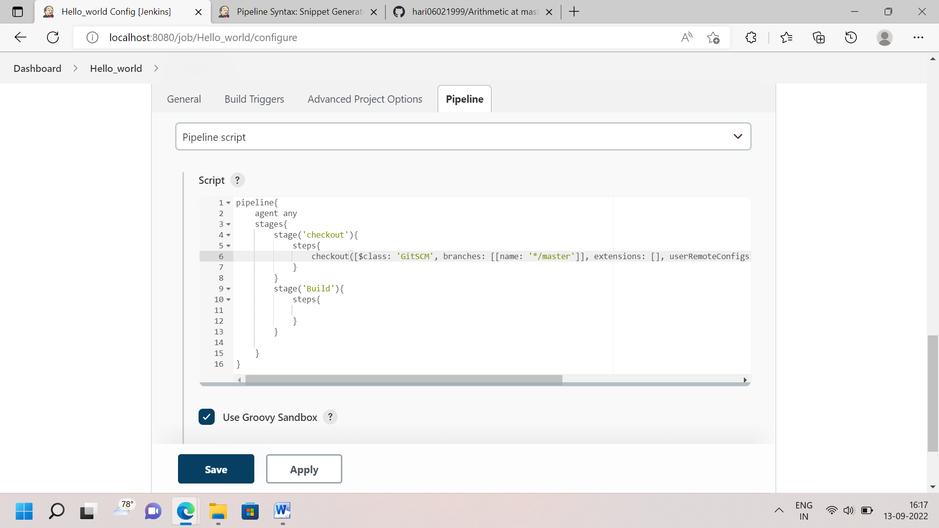

Step 3: Again I go snippet generator and I choose bat:Windows batch script. Just I write file name c program and generate script then copy the script 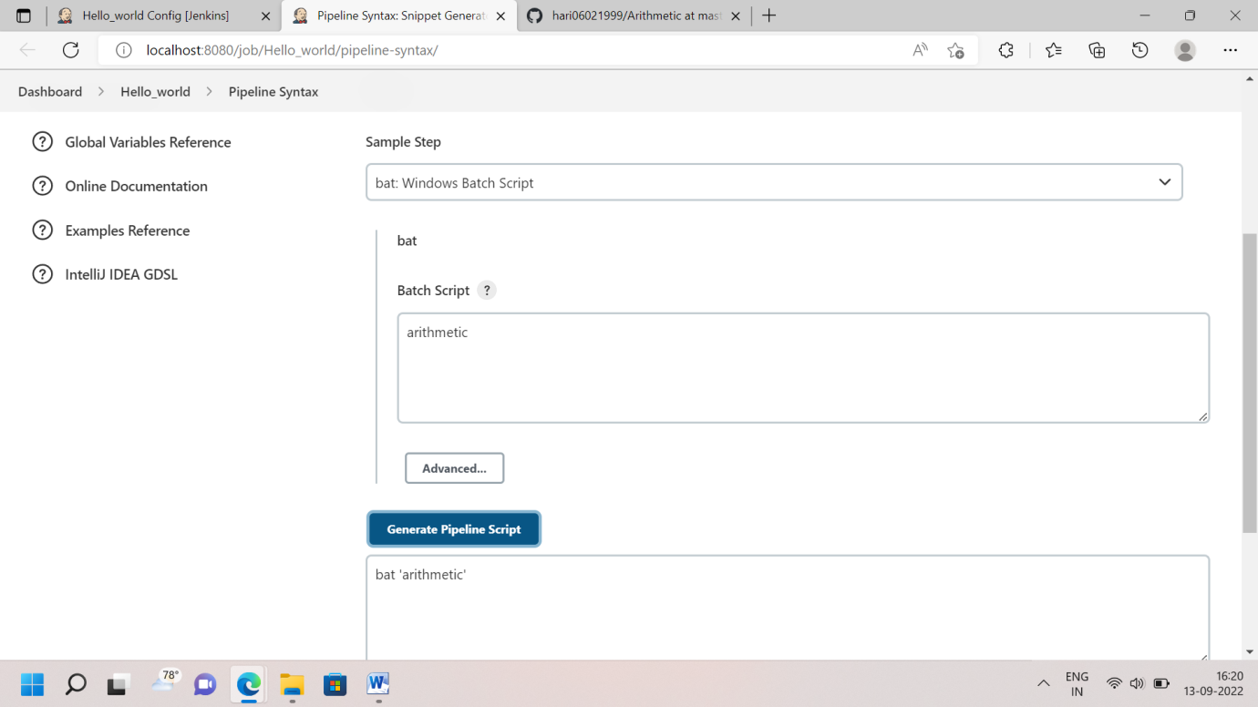

Step 4: To paste in Pipeline script- Build stage and Apply and save

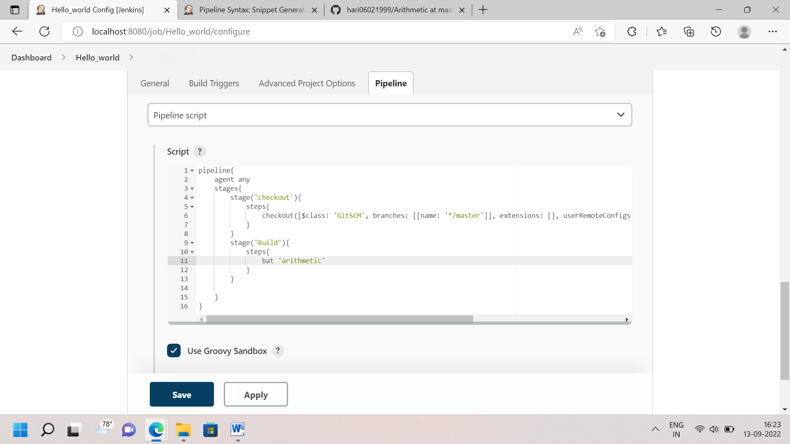

Step 5: Build now and View Console Output 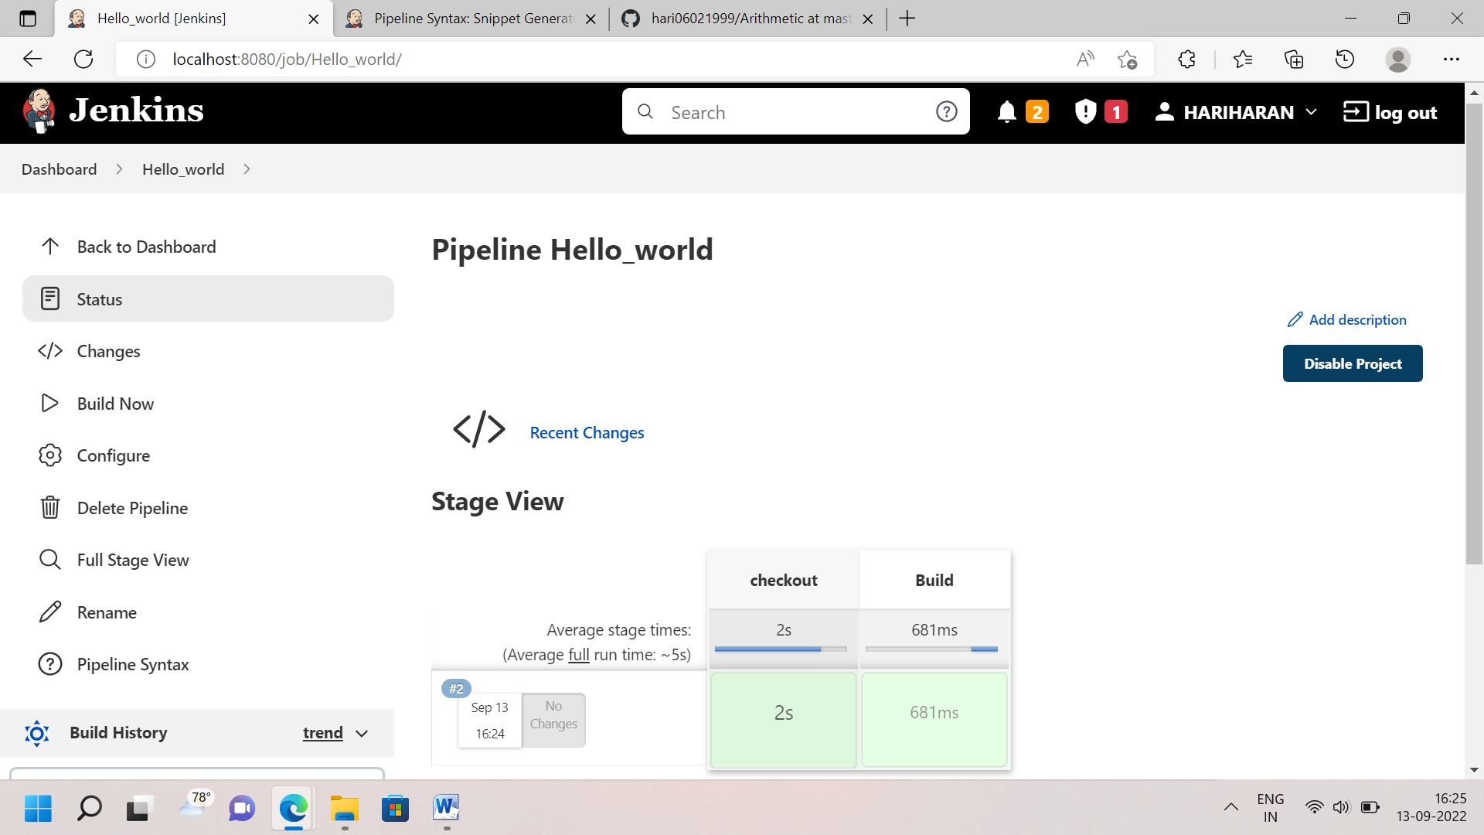

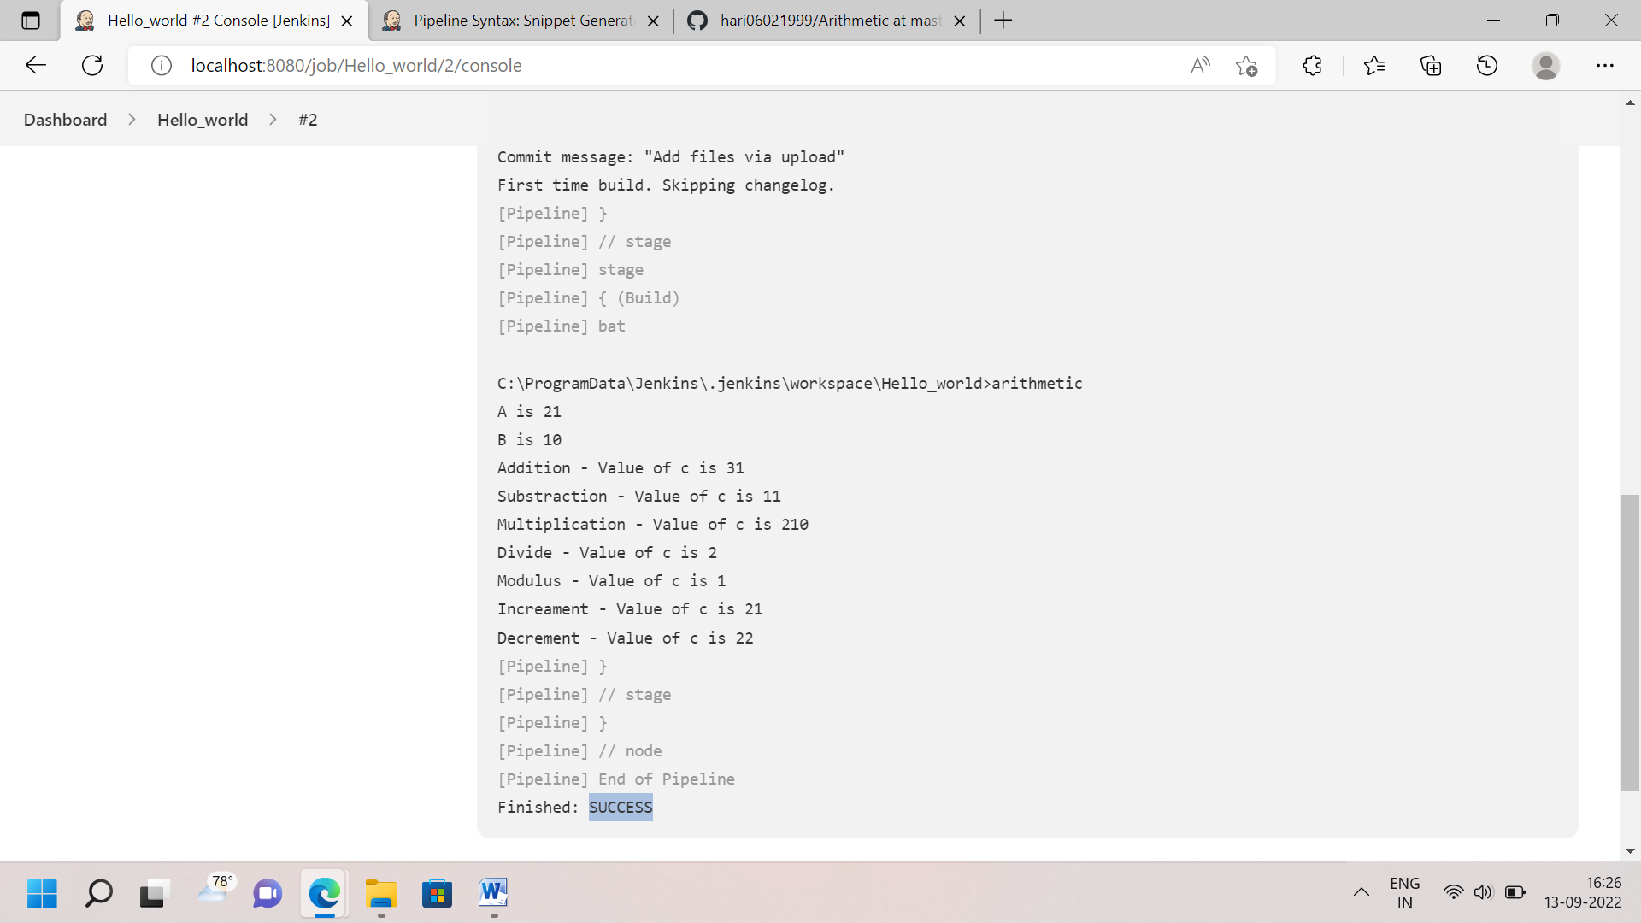

TYPE-3: Pipeline Script Mode – Basic Java

Step 1: I go to same project. Directly I go to pipeline script. I declare tools in global for build purpose. And I checkout the git project and generate pipeline script- copied to paste it script.

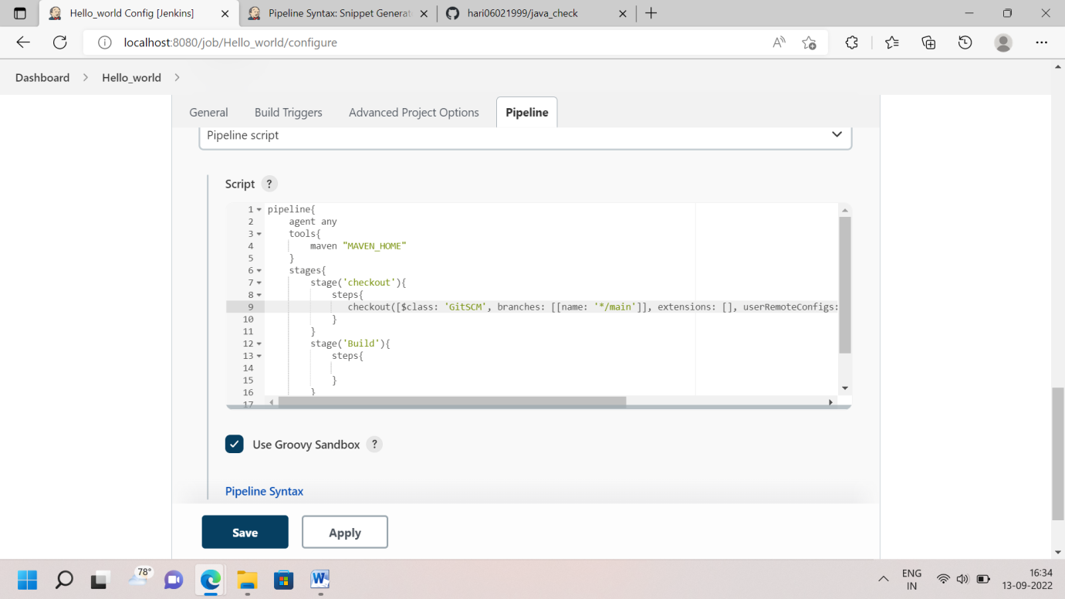

Step 2: Then I go to next stage- build. I choose bat: Windows batch script and write maven command like mvn clean install to generate script paste it pipeline script. 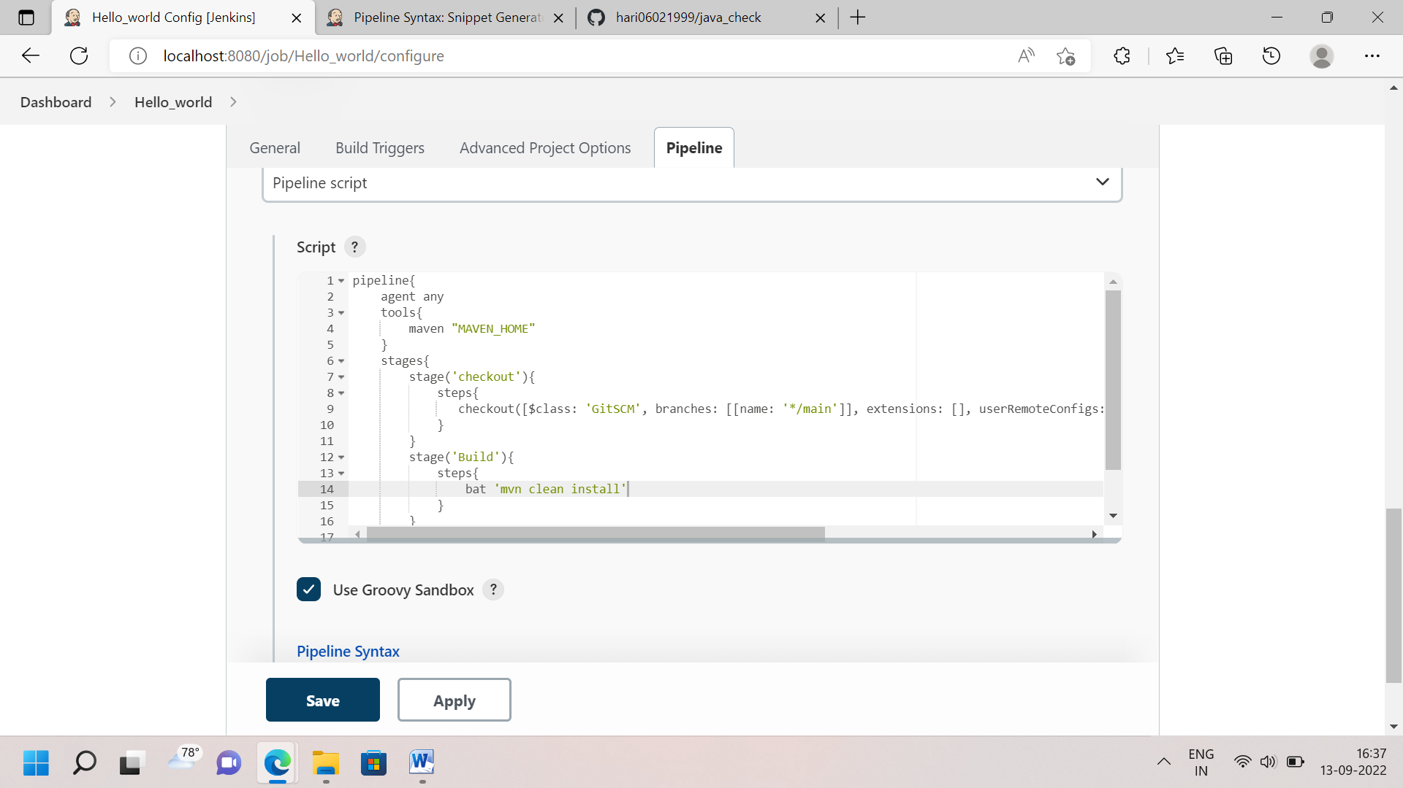

Step 3: Build now and to view console output

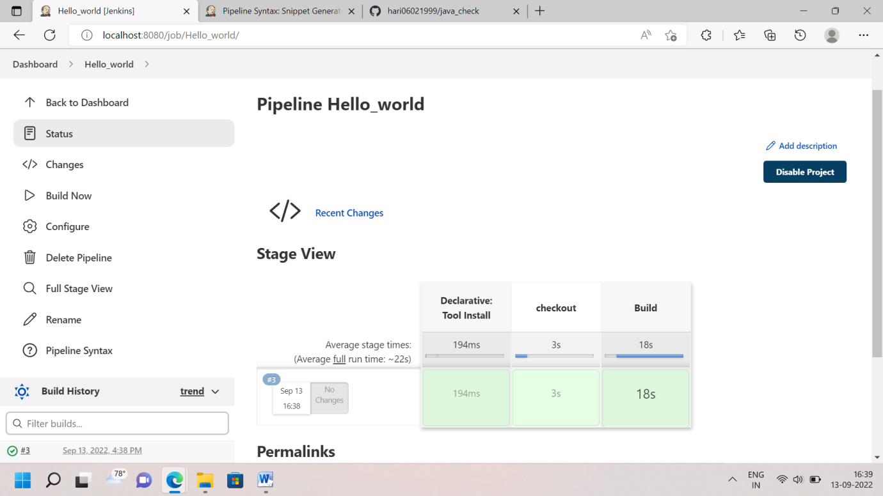

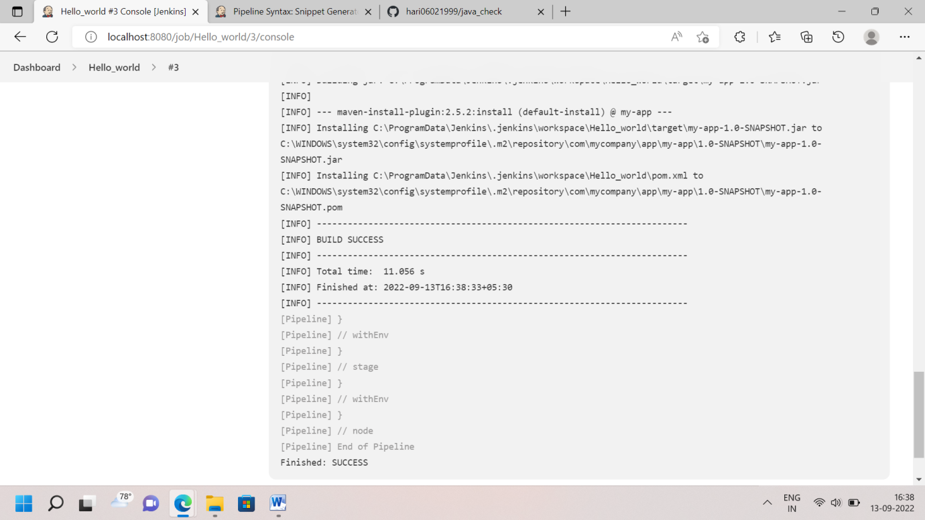

TYPE-3: Pipeline Script from SCM

Step 1: I’m changing Pipeline script to Pipeline script from SCM in Same Project file. And I choose SCM in Git. 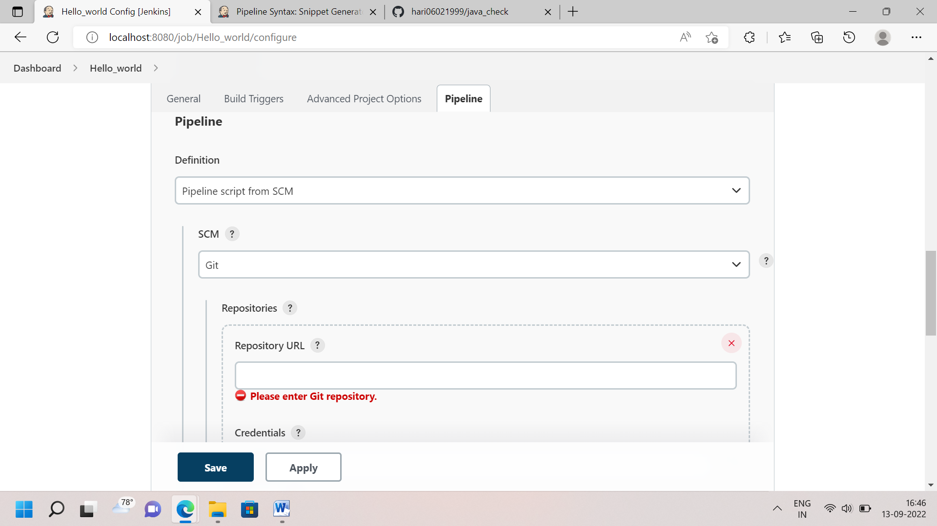

Step 2: Now I go Git Repository, it’s must have -**Jenkinsfile** this format

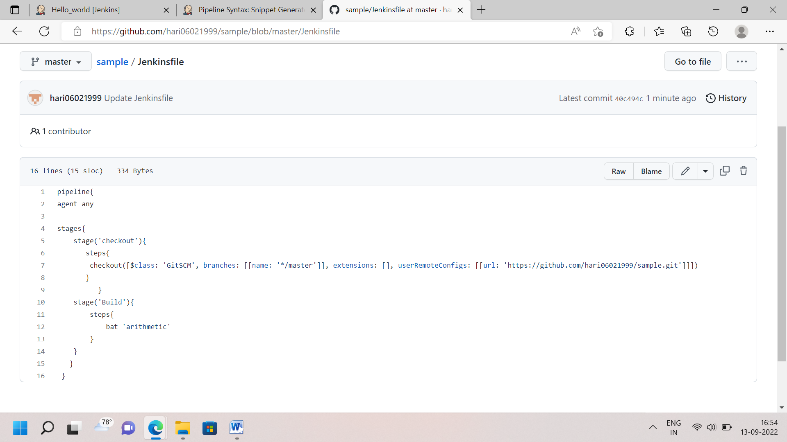

Step 3: Then Copy the Repository URL and Paste it Pipeline Script from SCM in Jenkins. And verify the Script path and Repository in Same as Jenkinsfile.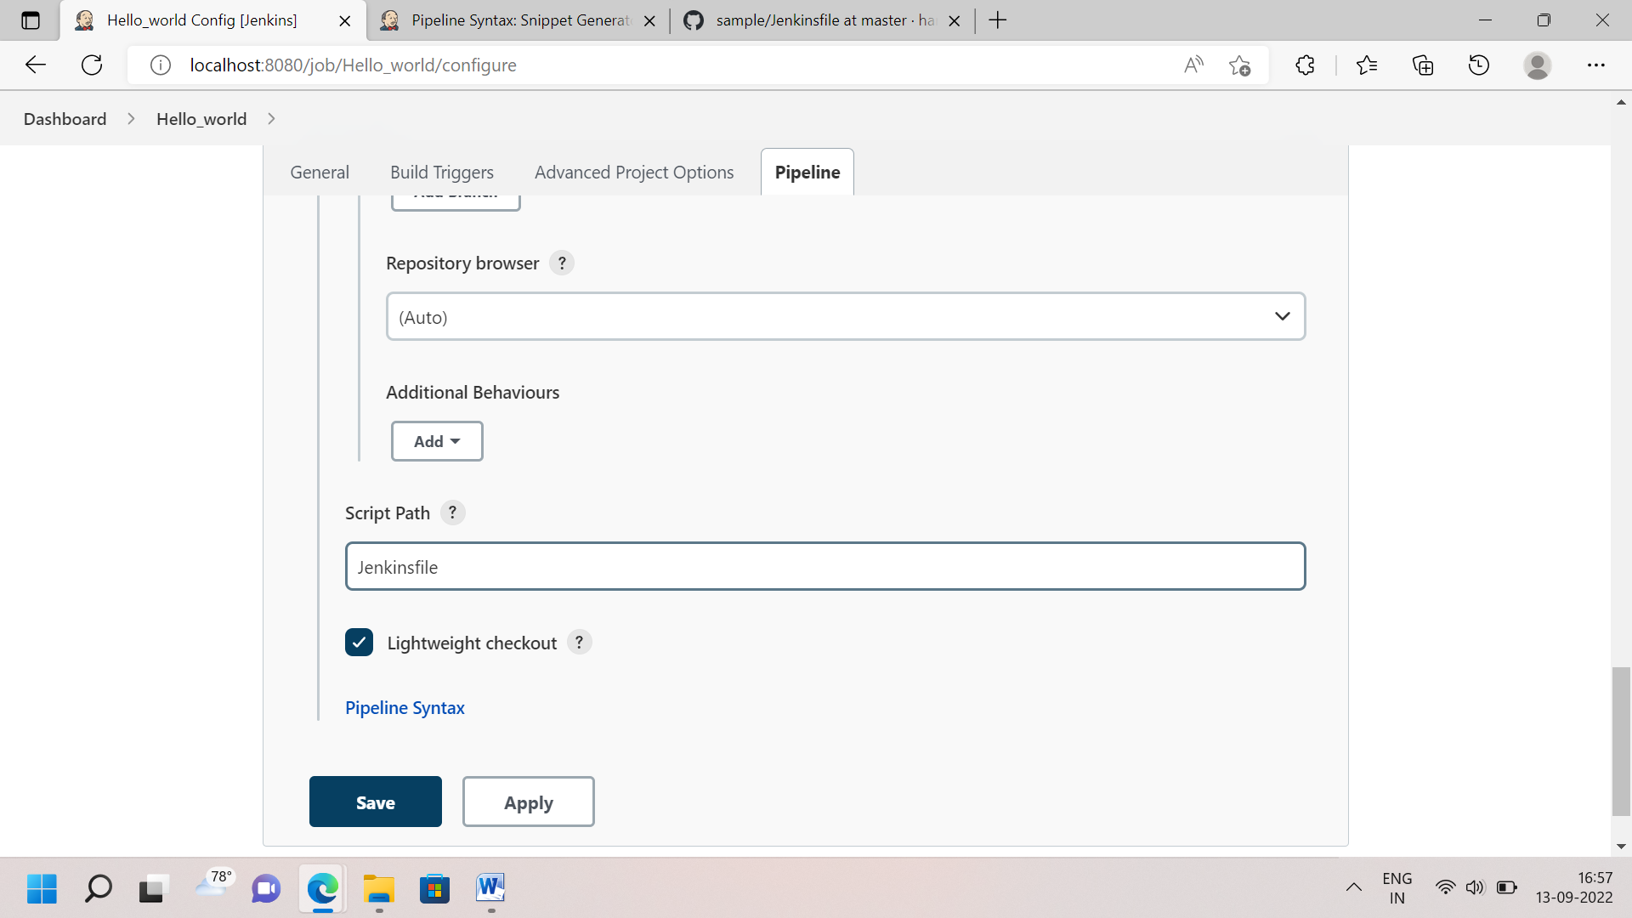

Step 4: Apply and Save. Build Now & View Console Output

